Author: Alizamin Ibrahimov
Country: Azerbaijan
E-mail: aibrahimov1998@gmail.com

"Research on Unsteady Flow Fluctuations in Lobe Pumps Using Lattice Boltzmann Method: High-Fidelity Simulation and Rotor Profile Optimization"

ABSTRACT

In the present study, the flow pulsation characteristics inherent to lobe pumps are rigorously examined. As a subclass of positive displacement pumps, lobe pumps inherently induce substantial periodic acceleration and deceleration of the working fluid within the control volume, resulting from the intermittent nature of fluid conveyance associated with their mechanical operation. This cyclic modulation in flow velocity gives rise to pronounced pulsations, which in turn generate both fluid-borne noise and mechanical vibrations due to fluctuating pressure fields acting upon the pump casing, as well as the inlet and outlet conduits. Moreover, these pulsations impose dynamic, oscillatory forces on the rotating shafts of the lobes, leading to persistent vibrations—an undesirable phenomenon that can precipitate premature mechanical degradation and contribute to structure-borne acoustic emissions.
The core focus of this investigation lies in assessing the influence of lobe geometry—recognized as the principal actuator of the pumping mechanism—on the resultant pulsation behavior. To this end, two distinct lobe configurations are modeled and subjected to comparative numerical analysis: a conventional straight-profiled lobe and an alternative design featuring a helically inclined profile. The principal objective is to elucidate the role of helical inclination in modulating pulsation intensity, while simultaneously evaluating its practical implications—both advantageous and detrimental—for industrial applications. To ensure fidelity to real-world operational conditions, an unsteady (transient) flow regime is employed in the computational fluid dynamics (CFD) simulations.
To facilitate a comprehensive assessment, strategically positioned monitoring points are established at critical locations within each pump, including the inlet, outlet, and internal control volume. At these loci, time-resolved measurements of pressure and velocity pulsations are acquired, enabling a detailed characterization of internal flow dynamics. The analysis extends beyond a mere pointwise comparison; it encompasses a spatial evaluation of pulsation phenomena throughout the internal flow field of each pump configuration. Given the transient nature of the simulated data, advanced time-series regression techniques are utilized to ensure quantitative robustness in the interpretation of results. The findings reveal that the geometric configuration of the lobes—particularly the helical inclination—exerts a substantial influence on the pulsation characteristics of the pump. These effects are subsequently analyzed in both temporal and spectral (frequency) domains, and the implications are discussed comprehensively in the concluding section of the paper.

Keywords: Lobe pump pressure pulsation, helical lobe pump pressure pulsation, lobe pump flow ripple, helical lobe pump flow ripple, effect of helical lobe profile on pressure pulsation

- INTRODUCTION

Lobe pumps have found extensive application across a wide spectrum of industries, including but not limited to food processing, pharmaceuticals, biotechnology, beverage production, and the pulp and paper sector—particularly in processes where fluid hygiene, gentle handling, and precision are paramount. Their design inherently supports sanitary operation, making them especially suitable for sensitive environments such as those encountered in the food and medical fields, where contamination risk must be minimized. In certain niche applications, rotor profiles resembling butterfly geometries are employed to meet specific flow or structural requirements.
From a functional standpoint, lobe pumps operate based on the principle of positive displacement through synchronized counter-rotating lobes housed within a precision-engineered chamber. As the rotors revolve, volumetric cavities are cyclically created between the lobes and the pump casing. These expanding cavities induce a pressure drop at the inlet, thereby generating a localized vacuum that actively draws fluid into the pumping chamber. Continued rotation reduces the volume near the outlet, effectively propelling the fluid toward the discharge port without subjecting it to abrupt shear forces or turbulence. This mechanism not only ensures consistent conveyance but also preserves the integrity of shear-sensitive media.
One of the defining advantages of lobe pumps lies in their capacity to handle heterogeneous fluids, including those containing large suspended particulates. Unlike conventional pumping systems, lobe pumps are capable of transporting high-viscosity materials—such as fruit pastes, honey, slurries, jams, olives, and whole cherries—without inducing mechanical degradation or compromising product quality. This capability renders them uniquely advantageous in processing operations where both material preservation and volumetric accuracy are critical.
In terms of engineering and operational versatility, lobe pumps offer several practical benefits. Their modular design allows for straightforward installation, disassembly, and maintenance—often with minimal tooling—thereby reducing downtime and operational costs. The bidirectional flow capability enables flexible pipeline configurations, as inlet and outlet orientations can be adjusted to accommodate spatial constraints or process requirements. Furthermore, these pumps can be mounted either vertically or horizontally, with inlet/outlet positions customizable on lateral or axial planes, enhancing their adaptability within complex process layouts.
Material selection further enhances their applicability across a range of operating environments. While standard configurations may utilize cast steel, versions manufactured from high-grade stainless steel are readily available for hygienic or corrosive service conditions. Flow control is another area where lobe pumps exhibit superior performance; integration with variable frequency drives (VFDs) enables precise modulation of motor speed, facilitating highly accurate dosing and stable, pulsation-minimized delivery profiles.
Additionally, from a maintenance and lifecycle cost perspective, lobe pumps benefit from the availability of cost-effective, interchangeable spare parts. Their compatibility with various accessory systems and sealing technologies makes them highly adaptable to aggressive media, elevated temperatures, or challenging process parameters, thereby extending their operational reliability and economic viability across diverse industrial contexts.

- PROBLEM DEFINITION

It is well established that positive displacement pumps exhibit fundamentally distinct operational characteristics compared to centrifugal pumps, a divergence primarily attributable to the fundamentally different geometric configurations employed by each type. Unlike centrifugal pumps, which rely on dynamic energy transfer through a rotating impeller, the majority of positive displacement pumps utilize dual intermeshing rotors. Consequently, the mechanisms governing their suction and discharge phases are inherently dissimilar. The most salient manifestation of this disparity is observed in flow pulsation phenomena. These pulsations, predominantly arising from the cyclic acceleration and deceleration of the working fluid, encompass both flow rate and pressure fluctuations. Nevertheless, it is the pressure pulsations that exhibit the most pronounced contrast between the two pump categories.
Among positive displacement pumps, lobe pumps have garnered increasing industrial attention in recent years due to their robust performance and operational reliability. Structurally analogous to external gear pumps, lobe pumps are frequently regarded as a modified variant thereof, distinguished primarily by the substitution of lobes for traditional gear teeth. Owing to this similarity in design and operating principle, lobe pumps have, in many applications, superseded external gear pumps and are increasingly favored in diverse sectors. However, this structural resemblance also implies a shared susceptibility to pulsation-related challenges, thereby rendering lobe pumps a persistent subject of analytical and experimental investigation.
Flow pulsations serve as the principal driver of pressure pulsations, and they give rise to fluid-borne vibrations and acoustic emissions, both of which can induce deleterious effects on pump integrity and system performance. While a substantial body of literature addresses the influence of gear geometry on pulsation characteristics in external gear pumps, analogous studies focused on lobe pumps remain relatively sparse. This gap is particularly significant in light of the growing industrial interest in helical-lobe configurations, which are increasingly being adopted in modern pump designs. As such, there is a compelling need to investigate the extent to which lobe geometry — specifically, helical lobes — can be employed as a means of modulating and potentially mitigating pulsation phenomena in lobe pumps. The present study is thus devoted to examining the influence of lobe geometry on pulsation characteristics, with a particular emphasis on the implementation of helical lobes.

- LITERATURE REVIEW

As computational fluid dynamics (CFD) technology has advanced recently, several researchers have developed flow simulation techniques to address changes in the computational domain. As a result, the numerical calculation of the flow field inside rotary lobe pumps has been accomplished (Mimmi & Pennacchi, Citation1999; Valdès, Barthod, & Perron, Citation1999; Vogelsang, Verhülsdonk, Türk, & Hörnig, Citation1999). Spur gear pumps were given tooth profiles by Costopoulos, Kanarachos, and Pantazis (Citation 1988) in order to lessen flow rate volatility. Tong and Yang presented an integral synthesis method using the necessary flow rate function (Citation2005). The lobe pump employs a dimensionless flow rate expression known as "specific flow rate." The claw vacuum pump's gas flow was numerically simulated, and the pressure distribution brought on by the claw rotors' gas pressure was thoroughly predicted. Wang, Jiang, and Cai (Citation2015) suggested a novel circular arc claw rotor profile.
A periodic parabolic function describes the flow of the involute leaf lobe pump (Mimmi & Pennacchi, Citation 1994). Reflux's impact on the efficiency of the roots blowers was examined by Sun, Jia, Xing, and Peng (Citation 2018). They discovered that the experiment's findings and the outcome of the CFD simulation agree fairly well. Peng, Gui, and Fan (Citation 2018) computed the flow of a hypoid gear's complicated oil when it splashes into the tank. They discovered that the numerical method can produce an accurate prediction of the complex oil flow in the hypoid gearbox and can also be used to examine the oil flow and churning loss in the axle shell of an actual car.
Due of their unequal output flow, Huang and Liu (Citation 2009) used the k- turbulence model to simulate the flow in a roots blower with three lobes and compare the results to calculations made using semi-empirical methods. According to a claim made by Yang and Tong (2002), when two rotors are meshing, the position of the contact points causes a change in the amplitude of the periodic function. Ma, Luo, Zhang, Zhou, and Deng (Citation 2017) used the CFD method along with the dynamic mesh to investigate the dynamic properties of coupled valves in reciprocating oil-gas multiphase pumps. They discovered that under various working conditions, the lag angle of one cycle stays at 3° and the valve plates may grip or rebound before vibrating after reaching the elevator limiter.
Hwang and Hsieh (Citation 2006) suggested a novel type of variable trochoid ratio rotor profile, and the process of obtaining sealing performance and greater volumetric efficiency was examined. Hsieh and Hwang (Citation 2015) also advanced a brand-new cavity curve. Using an elliptic roller track, the curve was created around the long axis of the ellipse roller arc rolling terminus. Then, a simulation of the rotary lobe pump built on the curve model revealed that the flow characteristics had been enhanced. A novel rotor profile created by Kang and Vu (Citation 2014) significantly enhanced the performance of the pump.
They calculated the volume and analyzed the flow field while taking the number of pump lobes into account to determine how well the four profiles performed. The outcomes showed that there was a measurable impact of rotor shape on pump performance. Using the RNG k- turbulence model and dynamic grids, Li, Jia, Meng, Shen, and Sang (Citation2013) numerically examined the internal flow field in a two-vane involute rotary lobe pump.
- RESEARCH OBJECTIVE

Lobe pumps have demonstrated exceptional utility in applications requiring robust, cost-effective, and fixed displacement fluid transfer mechanisms. Owing to their structural simplicity and operational reliability, these pumps have found widespread implementation across a broad spectrum of engineering domains, including hydraulic control systems, power transmission units, automotive engineering, high-pressure cleaning technologies, and various fluid conveyance systems.
A defining operational characteristic of lobe pumps—akin to other positive displacement machines—is the inherent unsteadiness in port flow rates. These periodic fluctuations in flow inevitably induce corresponding variations in pressure, which manifest as undesirable mechanical vibrations and acoustic emissions within the downstream system components. The contemporary shift toward electrification across numerous technical sectors, particularly in mobile hydraulic systems, has further intensified the demand for low-noise, high-pressure-capable lobe pumps, thereby underscoring the necessity for enhanced pulsation mitigation strategies.
As outlined in the problem definition, the adverse implications of pressure and flow pulsations necessitate systematic investigation. The overarching objective of this research is to attenuate such pulsations through the optimization of rotor geometric parameters. Specifically, the study aims to investigate the internal flow field characteristics of both conventional straight-profile lobe pumps and their helical counterparts. Within this framework, a detailed analysis will be conducted to quantify the spatial and temporal variations of pressure and velocity fields at critical locations within the internal flow domain of each pump type.
Subsequently, the primary sources of vibration and pulsation phenomena will be identified, providing insight into their genesis and propagation mechanisms. Furthermore, the study seeks to evaluate and compare the pressure generation capabilities of both pump configurations by estimating the average outlet pressure values through regression-based data analysis techniques.
In the final phase of the investigation, a comparative assessment will be performed to evaluate the pulsation amplitudes and behavioral characteristics at corresponding points in both pump types. Based on these comparative metrics, the respective advantages and limitations of each design will be elucidated. This, in turn, will facilitate informed decision-making regarding the optimal application contexts for straight-profile versus helical lobe pumps.

- AN OVERVIEW OF SIMULATION TOOL

Engineering analysis can be performed using the robust Computational Fluid Dynamics (CFD) program XFlow. It makes use of a unique, fully Lagrangian technique that is particle-based and proprietary, making it simple to address issues with fluid-structure interaction, aerodynamics, aero-acoustics, moving parts, and other difficult issues.
To push the boundaries of CFD, SIMULIA XFlow employs the revolutionary Lattice-Boltzmann method. It enables engineers to simulate turbulent or highly dynamic systems and fluid-structure interaction realistically without using conventional meshing. A boat riding the waves, an airplane performing flying maneuvers, oil sloshing in a gearbox and many other complex behaviors may all be studied using advanced behaviors like liquid surface tension and free body motion.

Key features and technologies

Meshless approach to CFD: Because XFlow uses a particle-based, completely Lagrangian meshless technique, traditional fluid domain meshing is not necessary. Furthermore, surface complexity is not a constraint. XFlow is tolerant of the quality of the input geometry and is capable of handling moving bodies and deformable sections.
An innovative particle-based kinetic method that solves the Boltzmann and Navier-Stokes equations is a feature of XFlow. Modern Large Eddy Simulation (LES) modeling and sophisticated non-equilibrium wall models are also included in the solver.
Unified non-equilibrium wall function is used by XFlow to simulate the boundary layer, resulting in a single consistent wall model. There is no need to choose between different algorithms and deal with their unique restrictions because this wall model works in all scenarios.

Adjusting the resolved scales automatically to the user's needs improves the quality of the solution close to the walls and adapts to the wake as the flow changes, which refines the wake in a flexible manner.
Advanced modeling abilities: XFlow can handle huge and sophisticated models, and it makes it much easier to set up analyses with hierarchical structures, moving parts, rigid or enforced body motion, and contact modeling.
The XFlow solver also offers thermal analysis, transonic and supersonic flows, conjugated heat transfer, non-Newtonian flows, flow through porous media, and complex boundary conditions, such as the porous jump and fan models.

5.1 Governing Equations

The meshless approach within XFlow is particle-based and fully Lagrangian, which means that classic fluid domain meshing is not required. Also surface complexity is not a limiting factor. XFlow can handle moving bodies and deformable parts, and is tolerant to the quality of the input geometry. Lattice Boltzman method to be used for simulation will be explained step by step in this section.

5.1.1 Local Consveration of Mass

First of all, considering the mass of fluid ( density $ρ(x)$) within some control volume $Ω$. The total mass within the volume is expressed by the integral
$\text{M=}$ $\int_{\text{Ω}}{ }\text{ρ(x)}\text{dV}$

Since mass is conserved, we know that the only way mass can change is by a fluid influx or outflux, which can come from either a source or sink inside the control volume or from flow inside or outside the control volume. By stating the derivative of M with regard to time, we may formalize this:

$\frac{\text{d}}{\text{dt}}\int_{\text{Ω}}{ }\text{ρ(x)}\text{dV} \text{=} \text{-}\int_{\text{δΩ}}{ }\text{ρ(x)}\text{v}\text{⋅}\text{ndA}\text{-}\int_{\text{Ω}}{ }\text{QdV}$

If there is no flow into or out of our system, we can assume that Q, the generic source or sink term in the equation above, is equal to zero. The flow into or out of the boundary is represented by the integral over the boundary, and the velocity at x is represented by v. Using the surface integral and the divergence theorem, we discover that
$\frac{\text{d}}{\text{dt}}\int_{\text{Ω}}{ }\text{ρ(x)}\text{dV} \text{=} \text{-}\int_{\text{Ω}}{ }\text{∇}\text{⋅}\text{(ρ(x)v)+}\text{QdV}$

The full equation is obtained under the same integral if we reverse the order of integration and derivative.
$\int_{\text{Ω}}{ }\frac{\text{d}}{\text{dt}}\text{ρ(x)+}\text{∇}\text{⋅}\text{(ρ(x)v)+}\text{QdV}\text{=0}$

Since this implies to any control volume $Ω$, the integrand have to be equal to zero ; this assertion is the same as stating that mass have to be locally conserved:
$$\frac{\text{d}}{\text{dt}}\text{ρ(x)+}\text{∇}\text{⋅}\text{(ρ(x)v)+Q=0}$$

We obtain a straightforward and concise equation for the local conservation of mass if we assume there are no sources or sinks:
$$\overset{\text{˙}}{\text{ρ}}\text{+}\text{∇}\text{⋅}\text{(}\text{ρv}\text{)=0}$$

5.1.2 Local Conservation of Momentum

In order to get started, let's review Newton's third law of force and acceleration:
$$\text{F=}\text{ma}$$

This can be expressed in continuum form by using densities as a substitute and assuming a "body force" b:
$$\text{b=ρ(x)}\frac{\text{d}}{\text{dt}}\text{v}.$$

The full derivative is then substituted to enlarge the acceleration:

$$\frac{\text{d}}{\text{dt}}\text{v=}\frac{\text{∂v}}{\text{∂t}}\text{+}\frac{\text{∂v}}{\text{∂x}}\frac{\text{∂x}}{\text{∂t}}\text{+}\frac{\text{∂v}}{\text{∂y}}\frac{\text{∂y}}{\text{∂t}}\text{+}\frac{\text{∂v}}{\text{∂z}}\frac{\text{∂z}}{\text{∂t}}\text{=}\frac{\text{∂v}}{\text{∂t}}\text{+}\text{∇}\text{v}\text{⋅}\text{v}$$
This results in the following equation for local momentum conservation:
$$\text{b=ρ}\frac{\text{∂v}}{\text{∂t}}\text{+}\text{ρ}\text{∇}\text{v}\text{⋅}\text{v}$$

Two equations for the conservation of fluid mass and momentum have been developed:
$$\begin{matrix}\overset{\text{˙}}{\text{ρ}}\text{+}\text{∇}\text{⋅}\text{(ρv)} & \text{=0} \\ \text{ρ}\frac{\text{∂v}}{\text{∂t}}\text{+ρ}\text{∇}\text{v}\text{⋅}\text{v} & \text{=b}\end{matrix}$$

The forces operating on the fluid (represented by b) are not as obvious as the central parameters of these equations, ρ and v, which are simple to reason about intuitively. The assumption about the set of body forces b is usually the following stage, followed by other simplifications, until the equation can finally be discretized ingeniously and simulated.
For Newtonian fluids, for example, we assume that the internal fluid stress resulting from the fluid's pressure makes up the majority of the body forces. The resulting system is essentially a system of second order nonlinear partial differential equations in seven dimensions (time, three spatial dimensions, and three velocity dimensions); simulating these accurately and effectively is possible but quite challenging, and frequently leads to numerical issues in addition to computational efficiency issues. (For example, even if it is assumed that the flow is completely inviscid, unsophisticated implementations of incompressible fluid flow will include numerical mistakes that are identical to an additional viscosity term.)
Instead of going into more depth, we take a different route and turn to the Boltzmann equation.

5.1.3 Boltzmann Transport Equation

The Boltzmann equation's core premise is that a system can be represented as a probability distribution over particles. Each particle is connected with a probability density f(x,v,t), which shows the likelihood that the particle will be at position x with velocity v at time t. We may obtain a collision-free version of the Boltzmann transport equation from this presumption.

Describe a particle of mass m, at time t with velocity v at position x Assume that this particle is being affected by force F as well. Due to basic Newtonian physics, it is known that the particle will retain its mass m , however be at position x+Δtv and have velocity $\text{v+}\text{Δ}\text{t}\frac{\text{F}}{\text{m}}$ . This justification can be expanded to include our probability density function and an infinitesimal time increment, Δt=δt :

$$\text{f(}\text{x,v,t}\text{)=f(}\text{x+vδt,v}\text{+}\frac{\text{F}}{\text{m}}\text{δt,t+δt}\text{)}$$

We can utilize this to take the derivative, resulting:

$$\underset{\text{δt→0}}{\text{lim}}\frac{\text{1}}{\text{δt}}\text{(f(}\text{x+vδt}\text{,} \text{v+}\frac{\text{F}}{\text{m}}\text{δt} \text{,}\text{t+δt}\text{)-f(}\text{x,v,t}\text{))=0}$$

If we express x and v as functions of t, we can use the chain rule to reach the same conclusion. The equation is obtained by evaluating this limit:

$$\begin{matrix}\frac{\text{∂f}}{\text{∂t}}\text{+}\frac{\text{∂f}}{\text{∂x}}\frac{\text{∂x}}{\text{∂t}}\text{+}\frac{\text{∂f}}{\text{∂v}}\frac{\text{∂v}}{\text{∂t}} & \text{=}\frac{\text{∂}}{\text{∂t}}\text{f+}\frac{\text{∂x}}{\text{∂t}}\text{⋅}{\text{∇}}_{\text{x}}\text{f+}\frac{\text{∂v}}{\text{∂t}}\text{⋅}{\text{∇}}_{\text{v}}\text{f} \\ & \text{=(}\frac{\text{∂}}{\text{∂t}}\text{+}\frac{\text{∂x}}{\text{∂t}}\text{⋅}{\text{∇}}_{\text{x}}\text{+}\frac{\text{∂v}}{\text{∂t}}\text{⋅}{\text{∇}}_{\text{v}}\text{)f} \\ & \text{=(}\frac{\text{∂}}{\text{∂t}}\text{+v}\text{⋅}{\text{∇}}_{\text{x}}\text{+}\frac{\text{F}}{\text{m}}\text{⋅}{\text{∇}}_{\text{v}}\text{)f} \\ & \text{=0.}\end{matrix}$$
It is essential to state that in our notation, ${\text{∇}}_{\text{x}}$ and ${\text{∇}}_{\text{y}}$ are not directional derivatives, but rather basic shorthands for the gradient in the velocity and position spaces. Therefore, final collision-less Boltzmann transport equation is obtained:

$$\text{(}\frac{\text{∂}}{\text{∂t}}\text{+v}\text{⋅}{\text{∇}}_{\text{x}}\text{+}\frac{\text{F}}{\text{m}}\text{⋅}{\text{∇}}_{\text{v}}\text{)f=0}$$

To add in collisions, it is needed to provide a driving force to a system that evolves as a specific differential equation, so that typically alter it from a homogeneous to an inhomogenous equation. Therefore, we posit that we can depict a Boltzmann equation with collisions utilizing a collision operator $\text{Ω(t)}$, resulting:
$$\text{(}\frac{\text{∂}}{\text{∂t}}\text{+v}\text{⋅}{\text{∇}}_{\text{x}}\text{+}\frac{\text{F}}{\text{m}}\text{⋅}{\text{∇}}_{\text{v}}\text{)f=Ω(t)}$$

Shown this formula governing the system microscopic dynamics , macroscopic quantities of interest can be derived by integrating over f:
$$\begin{matrix}\text{Density:} & \text{ρ(x,t)} & \text{=∫f(x,v,t)dv} \\ \text{Momentum:} & \text{ρ(x,t)v} & \text{=∫vf(x,v,t)dv}\end{matrix}$$

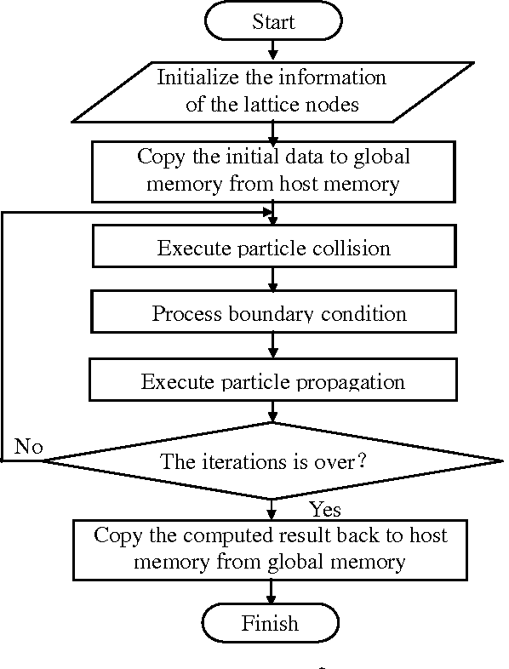
Lattice-Boltzman Method Flowchart

5.1.4 Discretization of the Boltzmann Equation

In order to simulate these equations, we must transform them into a set of algebraic equations via discretization. The Lattice Boltzmann Method is based on a somewhat strange discretization – we discretize time and space as usual onto a lattice with fixed width steps, and we discretize velocity into a finite number of potential directions. Discretization uses possible values, with $e_{0}$ corresponding to a zero velocity:
We need to discretize these equations into a collection of algebraic equations in order to simulate them. The Lattice Boltzmann Method is based on a peculiar discretization: we discretize velocity into a finite number of potential directions and discretize time and space as usual onto a lattice with fixed width steps. Discretization makes use of potential values, where $e_{0}$ represents a velocity of zero:

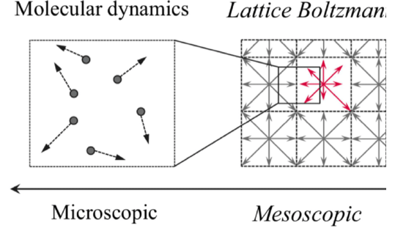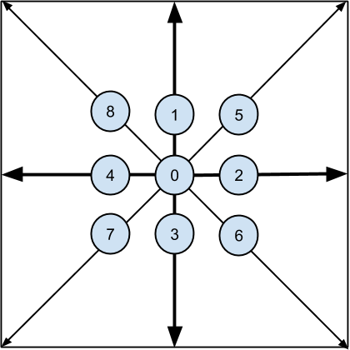
Fig Real molecules versus LB particles Fig Discretization

Now considering final reached formula:
$$\left(\frac{\text{∂}}{\text{∂t}}\text{+v}\text{⋅}{\text{∇}}_{\text{x}}\text{+}\frac{\text{F}}{\text{m}}\text{⋅}{\text{∇}}_{\text{v}}\right)\text{f=Ω}\left(\text{t}\right)$$

consider what happens when we fix a velocity of interest in order to discretize it in the velocity space, v=$e_{i}$, one of the nine directions indicated above. Doing the substitution it is obtained:
$$\left(\frac{\text{∂}}{\text{∂t}}\text{+}{\text{e}}_{\text{i}}\text{⋅}{\text{∇}}_{\text{x}}\text{+}\frac{\text{F}}{\text{m}}\text{⋅}{\text{∇}}_{\text{v}}\right)\text{f=Ω}\left(\text{t}\right).$$

As it is known from multivariable calculus, ${\text{e}}_{\text{i}}$⋅${\text{∇}}_{\text{x}}$ f is basicly the directional derivative in the direction $e_{i}$; that is how quickly the quantity changes when we proceed in the direction shown by ${\text{e}}_{\text{i}}$. Next, taking the gradient in velocity space into consideration
$${\text{∇}}_{\text{v}} \text{f} \text{=}\left(\frac{\text{∂f}}{\text{∂}{\text{v}}_{\text{x}}}\text{,}\frac{\text{∂f}}{\text{∂}{\text{v}}_{\text{y}}}\text{,}\frac{\text{∂f}}{\text{∂}{\text{v}}_{\text{z}}}\right)$$

For proceeding, we have to evaluate ${\text{∇}}_{\text{v}} \text{f}$ (${\text{e}}_{\text{i}}$), which cannot be done generally. Therefore, we guess that F is zero for the time being; there are several methods to integrate body forces into the Lattice Boltzmann method, however, mostly the body forces are combined into the collision term, which will be discussed later.

Under this assumption, the formula simplifies to
$$\left(\frac{\text{∂}}{\text{∂t}}\text{+}{\text{e}}_{\text{i}}\text{⋅}{\text{∇}}_{\text{x}}\right)\text{f=Ω}\left(\text{t}\right)$$

if let ${\text{f}}_{\text{i}}$ be ${\text{f(}\text{x,e}}_{\text{i}}$,t) that turns

$${\text{f}}_{\text{i}}\text{(x+}{\text{e}}_{\text{i}}\text{δt}\text{,} \text{t+δt}\text{)-}{\text{f}}_{\text{i}}\text{(}\text{x,t}\text{)=}{\text{Ω}}_{\text{i}}\text{(t)}$$

According to Bhatnagar-Gross-Krook (BGK) assumption:
$${\text{Ω}}_{\text{i}}\text{=}\frac{\text{1}}{\text{τ}}\left({\text{f}}_{\text{i}}^{ \text{eq}}\text{-}{ \text{f}}_{\text{i}}\right)$$

Again according to Bhatnagar-Gross-Krook (BGK) assumption:
$${\text{f}}_{\text{i}}^{ \text{eq}}\text{=}{\text{ω}}_{\text{i}} \text{ρ(1+3}\frac{{\text{e}}_{\text{i}}\text{⋅}\text{u}}{\text{c}}\text{+}\frac{\text{9}}{\text{2}}\frac{\text{(}{\text{e}}_{\text{i}}\text{⋅}\text{u}{\text{)}}^{\text{2}}}{{\text{c}}^{\text{2}}}\text{-}\frac{\text{3}}{\text{2}}\frac{\text{u}\text{⋅}\text{u}}{{\text{c}}^{\text{2}}}\text{)}$$
where ${\text{ω}}_{\text{i}}$ is a weighting function that depends on the exact velocity discretization.

We divide the solution of the equation into the following parts for the implementation of LBM method:
$${\text{f}}_{\text{i}}\left(\text{x+}{\text{e}}_{\text{i}}\text{δt,} \text{t+δt}\right) \text{-} {\text{f}}_{\text{i}}\left(\text{x,t}\right)\text{=}{\text{Ω}}_{\text{i}}\left(\text{t}\right)$$
Simply computing this equilibrium and updating the relaxation constitutes the collision step:
$${\text{f}}_{\text{i}} \text{≔} {\text{f}}_{\text{i}}\text{-}\frac{\text{1}}{\text{τ}}\left({\text{f}}_{\text{i}}^{ \text{eq}} \text{-} {\text{f}}_{\text{i}}\right)$$

5.1.5 Numerical Setup and Simulation Details

The modeled lobe pumps were simulated using Dassault Systemes "Simulia XFlow" software, which is among the most suitable options for positive displacement pumps. 3 bar total pressure was applied at the inlet as a boundary condition, and at outlet 10 bar static pressure was applied. Water with an inlet temperature of 20 degrees was selected as working medium (newtonian). Additionally, reference density = 1000 kg/m3, dynamic viscosity = 8.90 × 10−4 Pa·s, thermal conductivity = 0.598 W/m·K and specific heat capacity: 4184 J⋅kg−1⋅K−1 were accepted. Transient simulation was applied as flow type, and the time step was set to be t = 0.0002 which means 0.72 degree of movement of lobe at each time step. Flow was simulated using Wall Adapting Large Eddy-Viscosity (wale) turbulence model. Pump geometry details can be found below tables 1 and 2:

Pump Casing Parameters
Wall thickness | W | 5 mm
Inlet pipe inner diameter |  | 95 mm
Inlet outer diameter |  | 107 mm
Inlet pipe length |  | 600 mm
Outlet pipe inner diameter |  | 95 mm
Outlet pipe outer diameter |  | 107 mm
Outlet pipe length |  | 600 mm
Casing inlet circle diameter |  | 153 mm
Radial tip clearance | C | 1.5 mm
Distance between center of gears |  | 106.8 mm

Table 1

Lobe Parameters
RPM | n | 600 RPM
Outer circle diameter | $$D_{out 3}$$ | 150 mm
Number of Leaves | z | 3
Body thickness | t | 150 mm
Helix angle | θ | 18 deg
Table 2

As mentioned earlier, the monitoring points were placed in the regions with the highest pressure and they can be observed below:

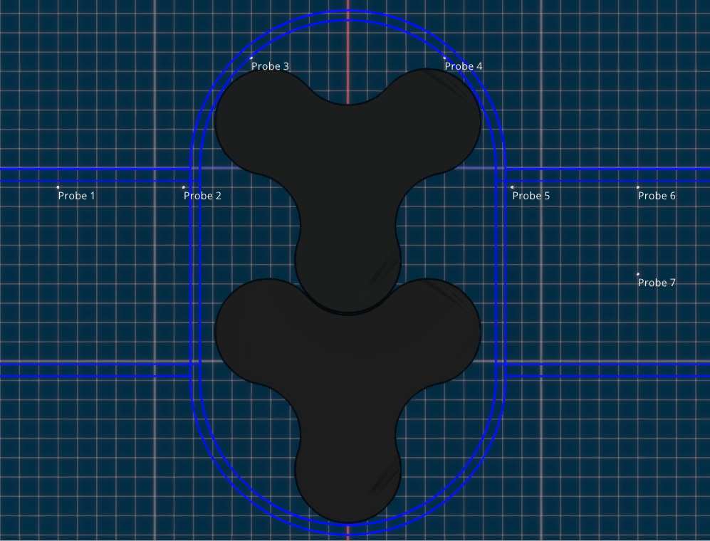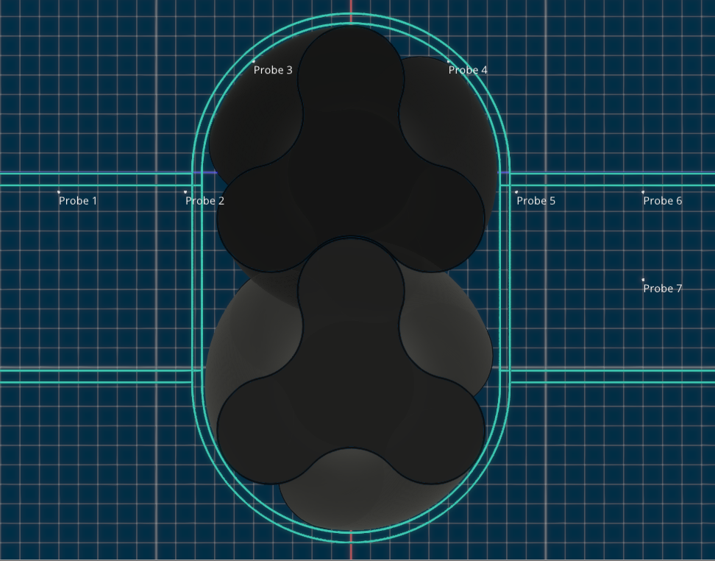
Straight Profile Lobe Pump monitoring points Helical Lobe Pump Monitoring Points

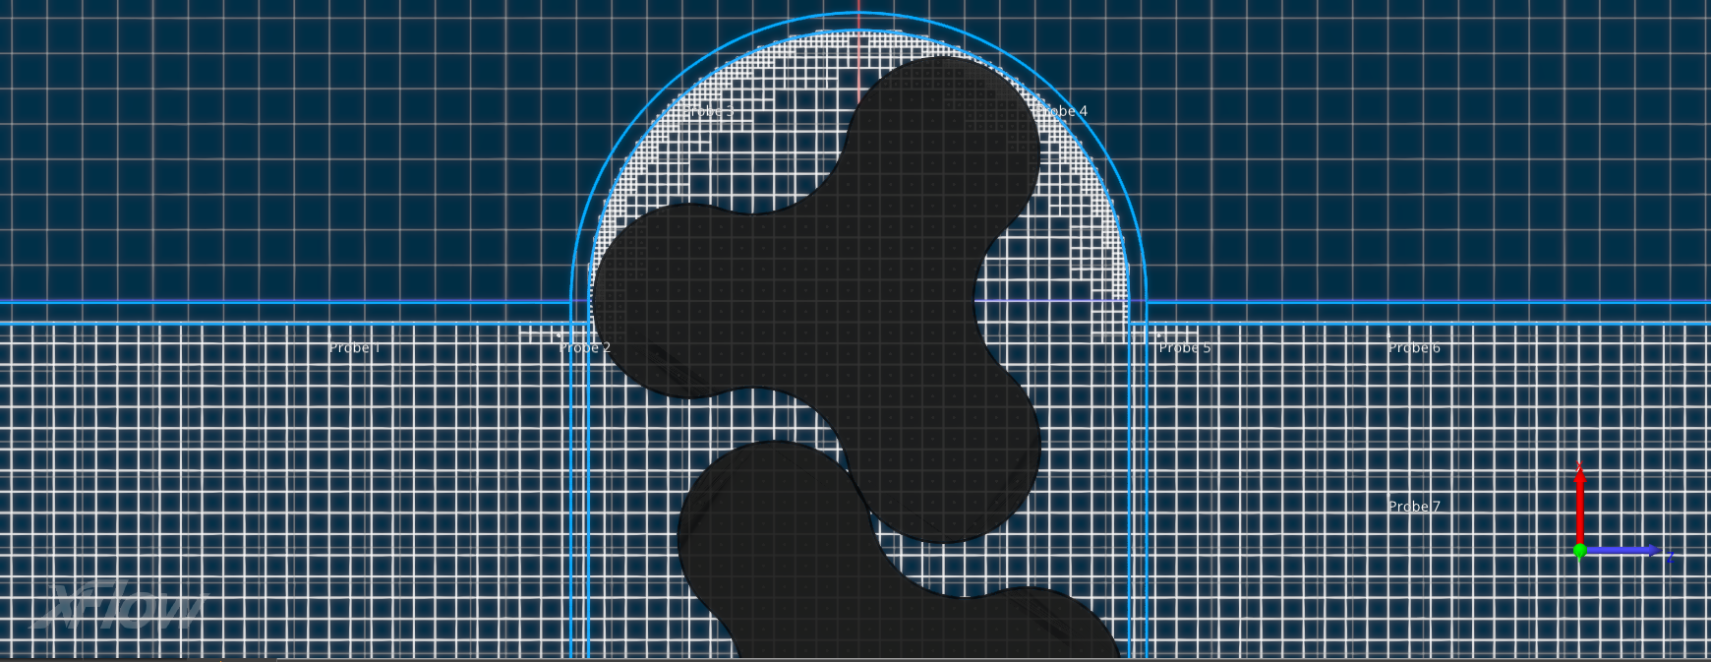
Straight Profile Lobe Pump Discretezation

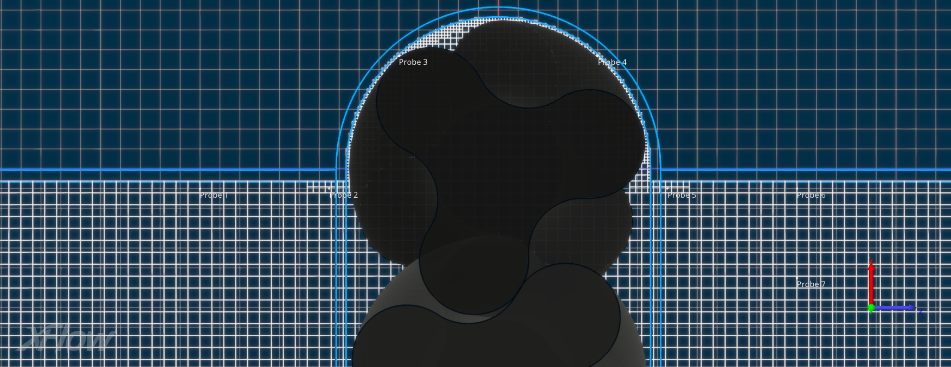
Helical Lobe Pump Discretezation

- SIMULATION RESULTS

Straight Profile Lobe Pump Simulation Data

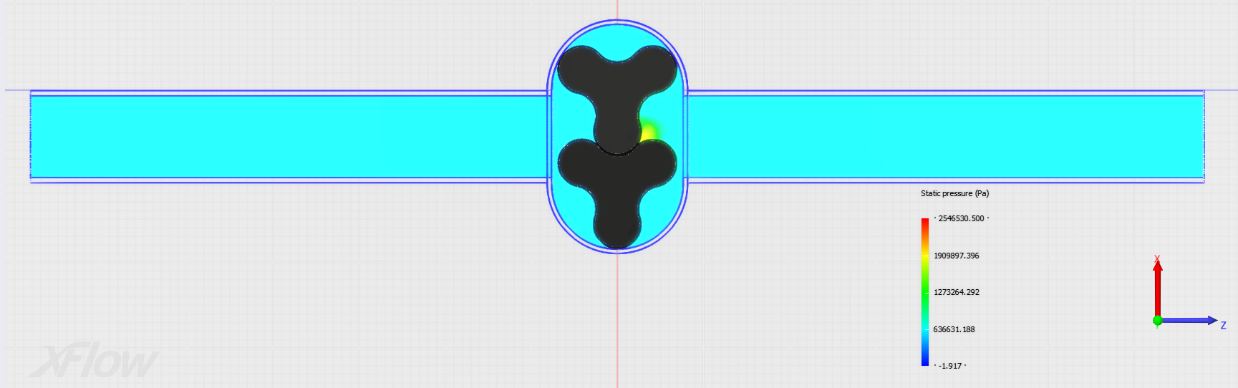
Pressure Profile of Straight Lobe Pump

Straight Profile Lobe Pump Unsteady Pressure Pulsation Graphs at Monitoring Points:

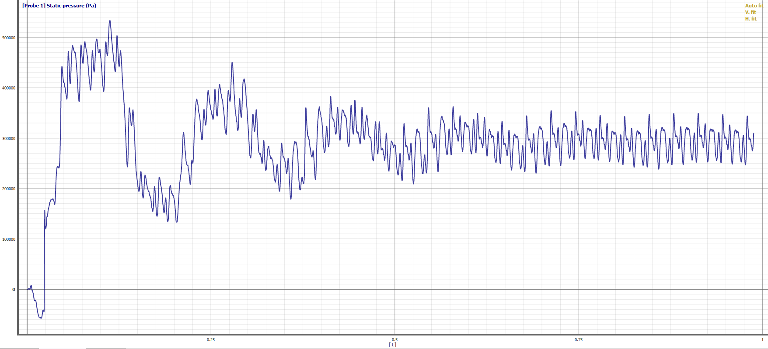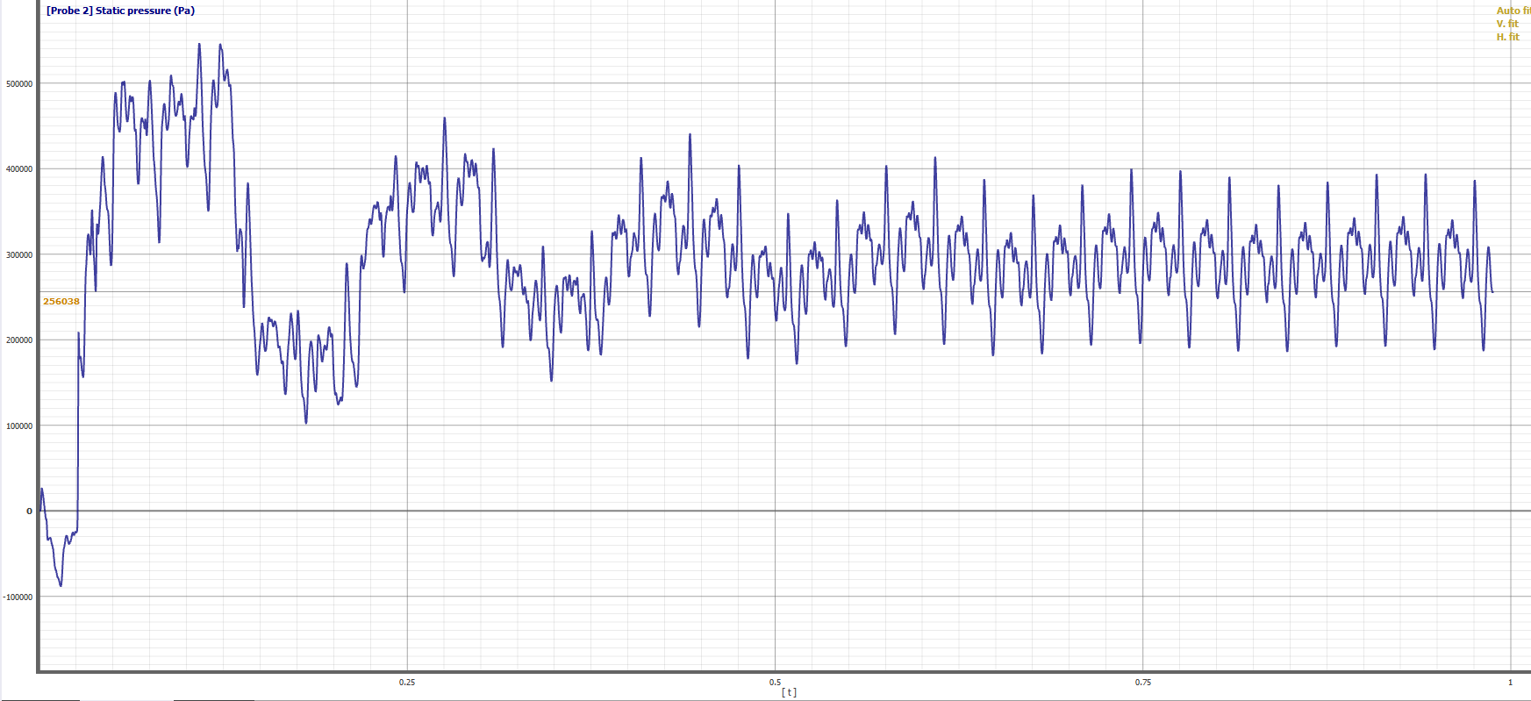
Probe 1 Probe 2

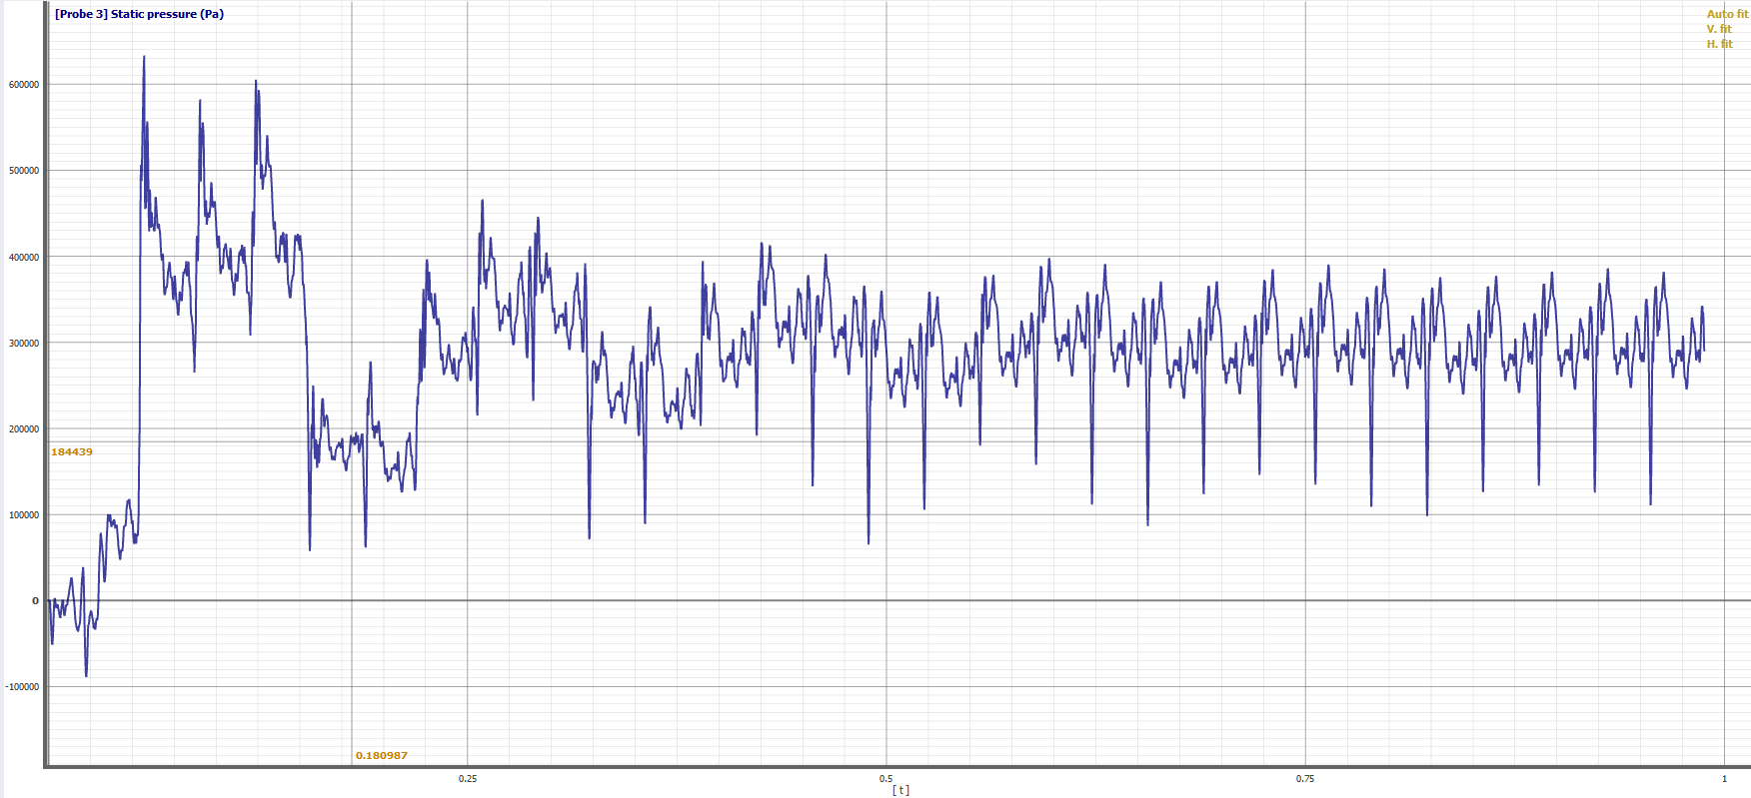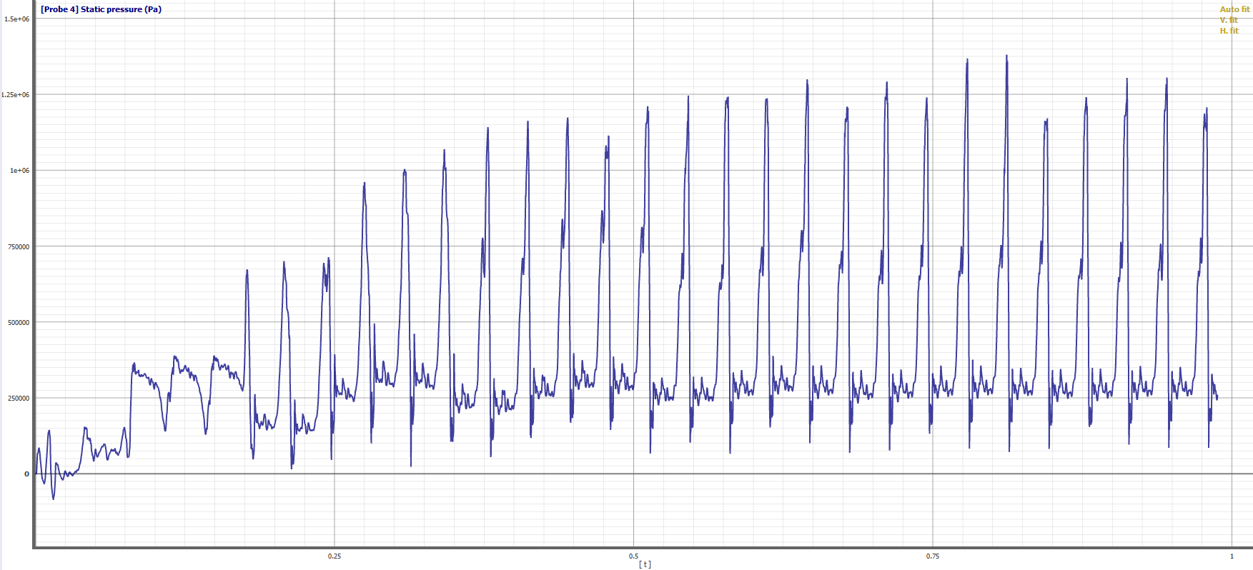
Probe 3 Probe 4

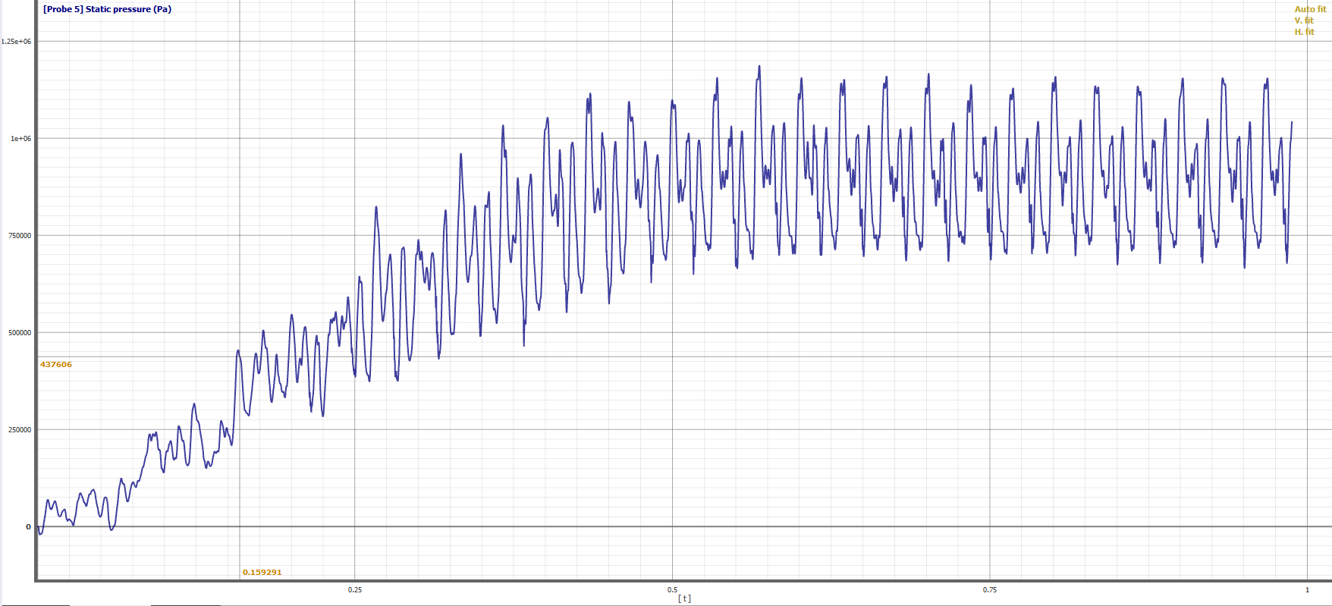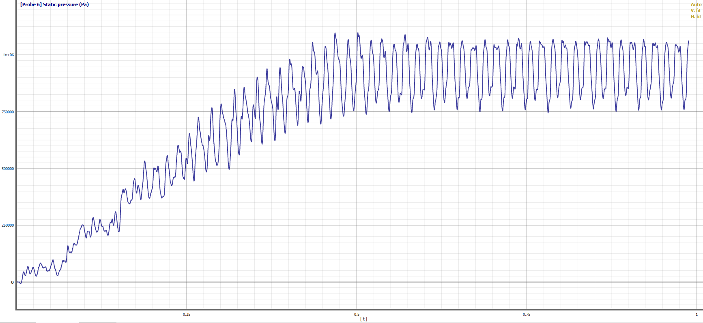
Probe 5 Probe 6

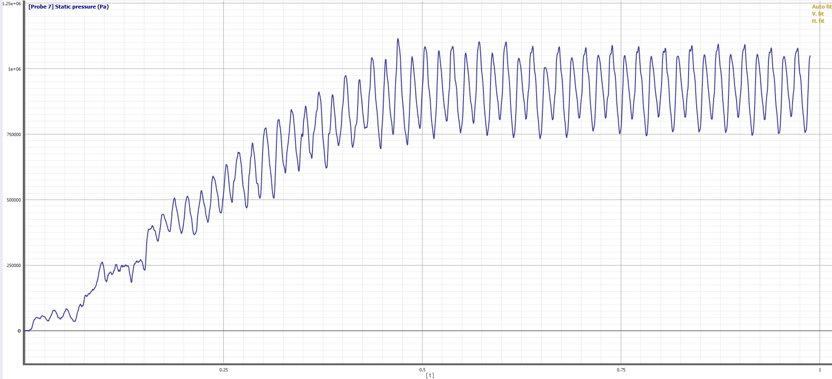
Probe 7

Straight Profile Lobe Pump Pressure Frequency Domains of Monitoring Points:

Each graph below represents frequency domains converted from time domain (time interval selected from 0.8s to 0.9s which is equal to one complete revolution of lobe) using Fourier transformation

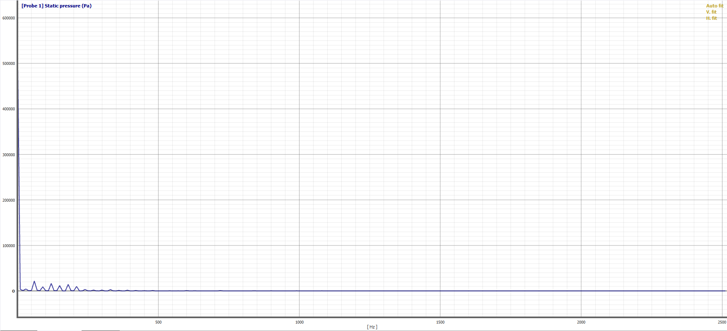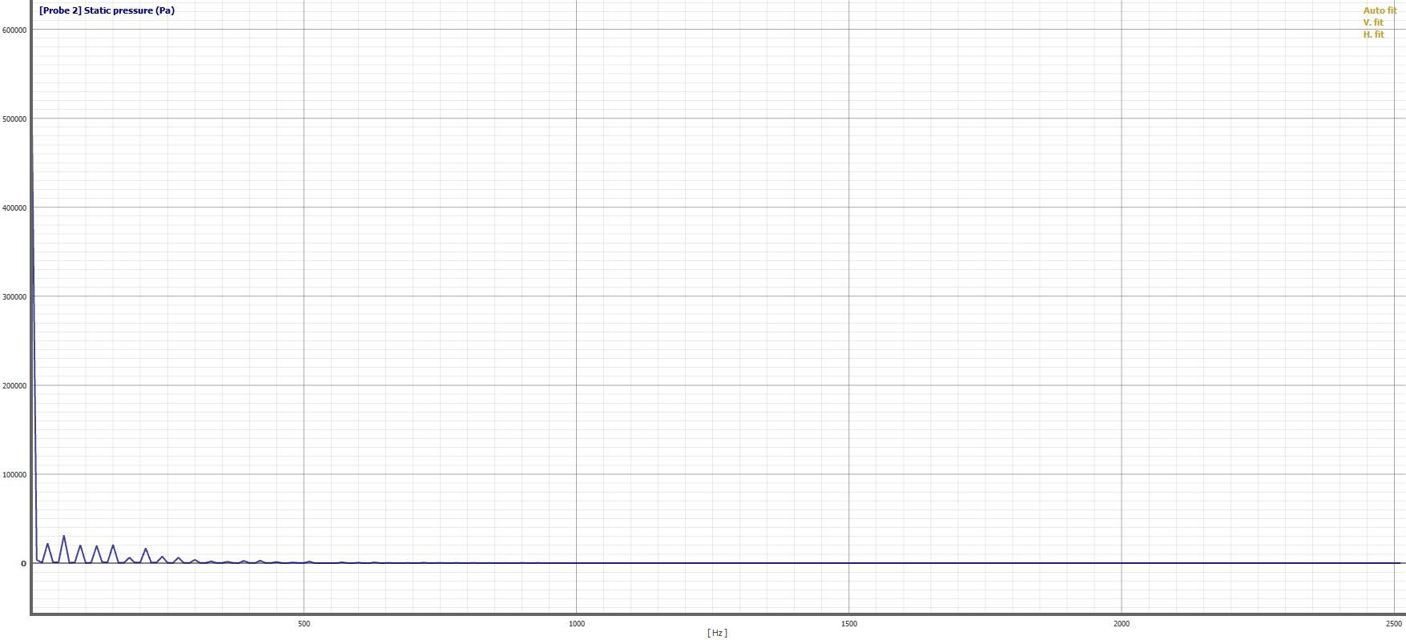
Probe 1 Probe 2

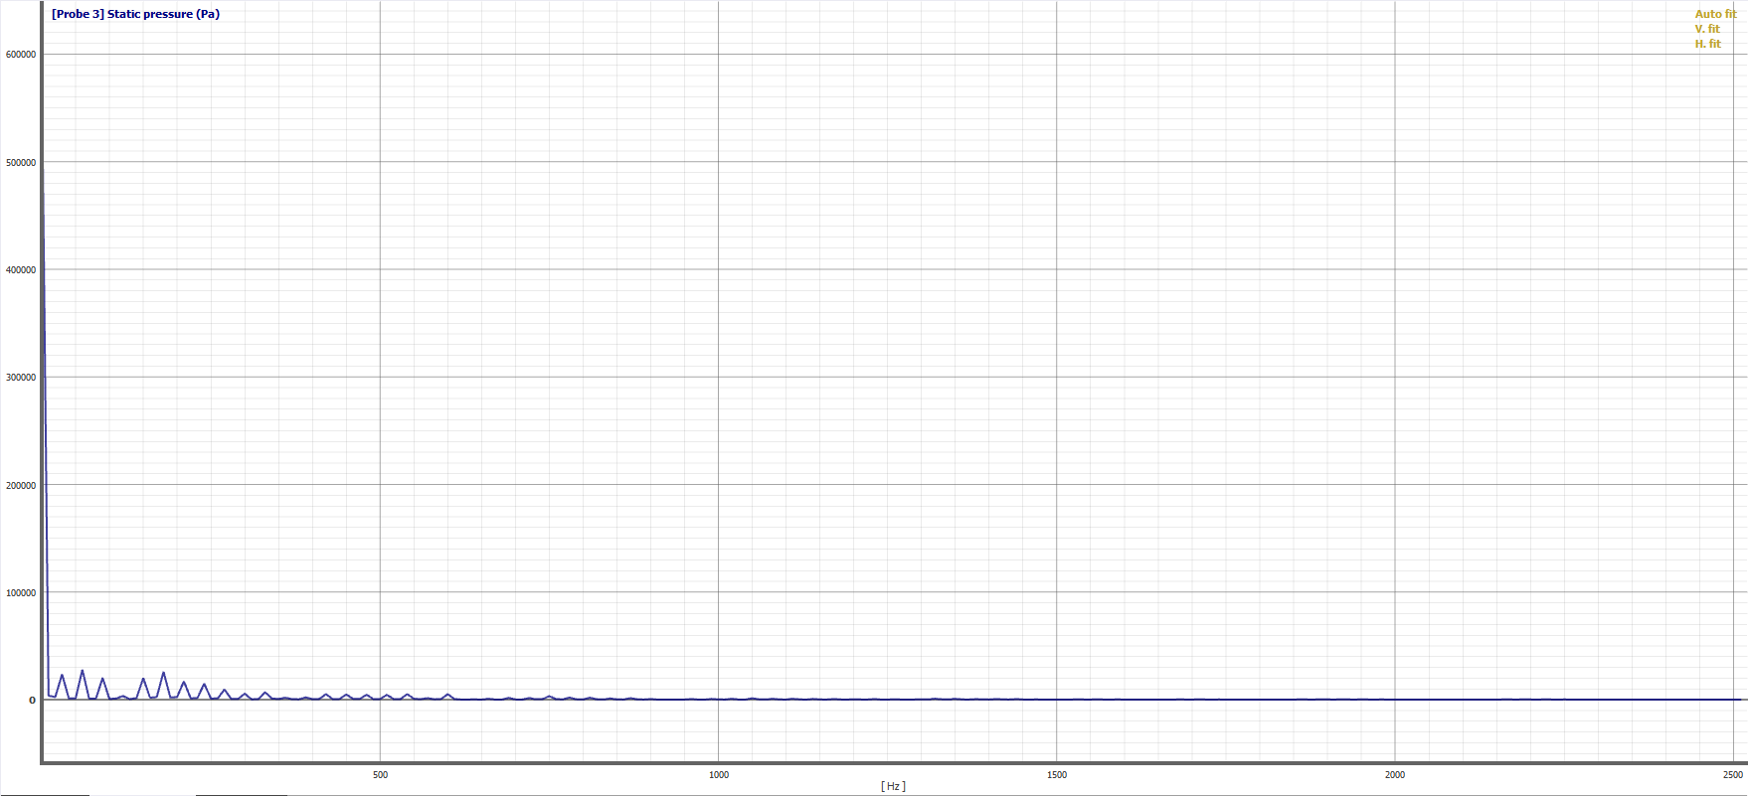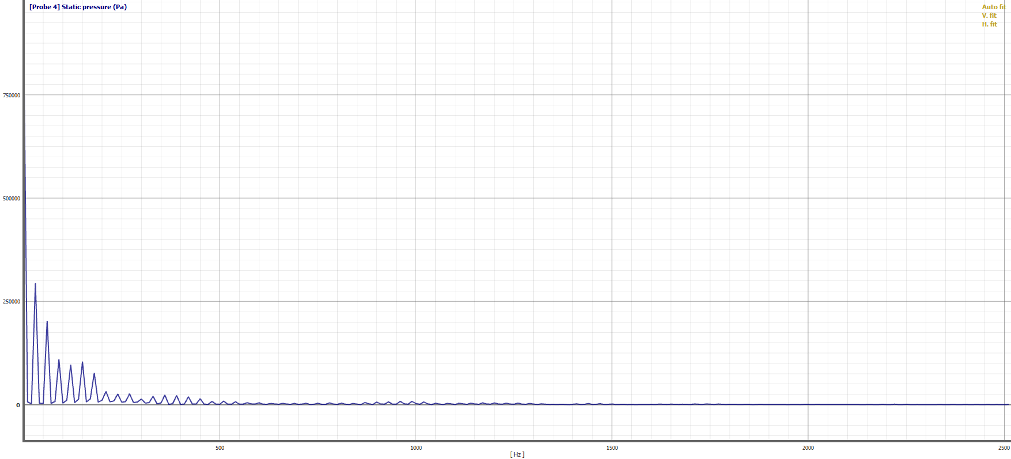
Probe 3 Probe 4

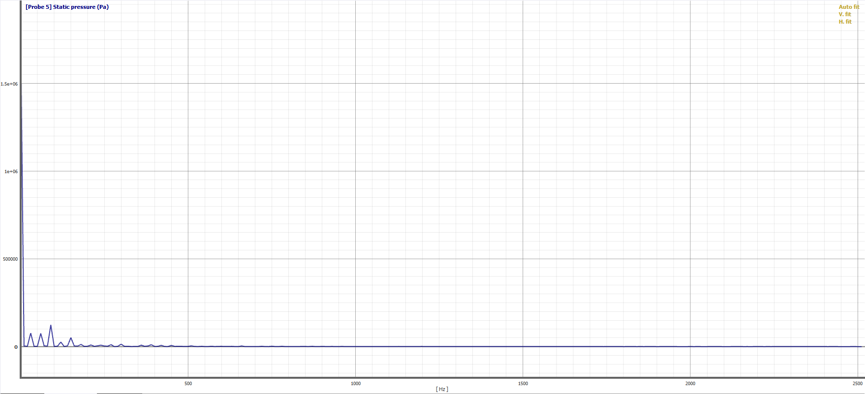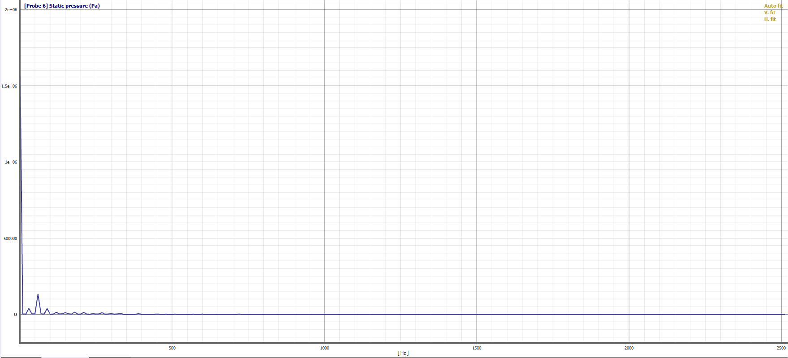
Probe 5 Probe 6

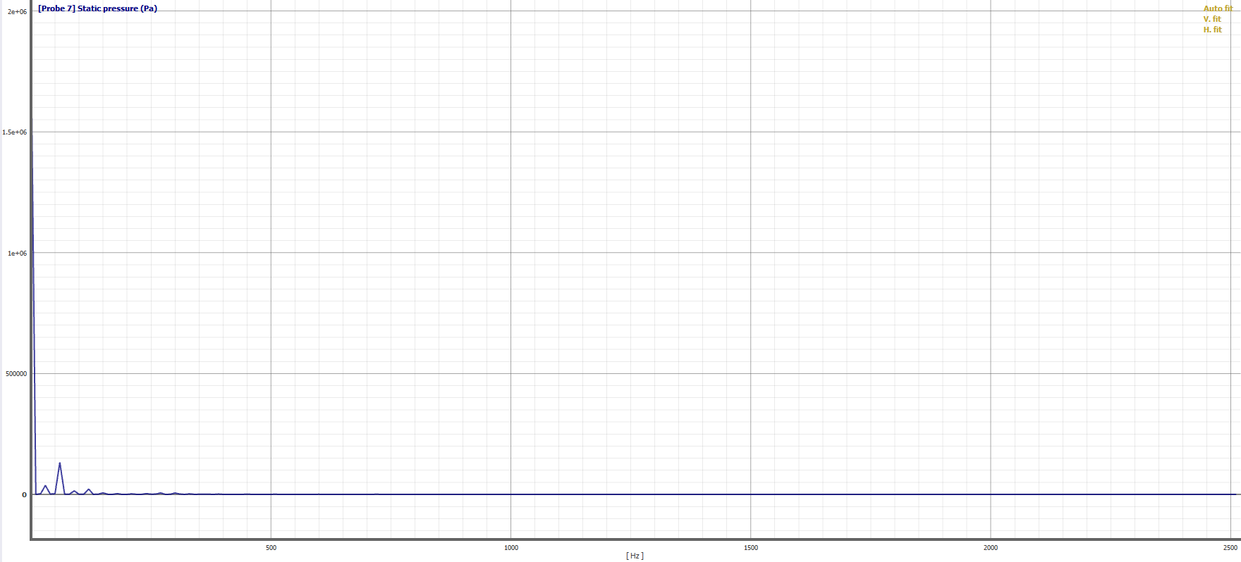
Probe 7

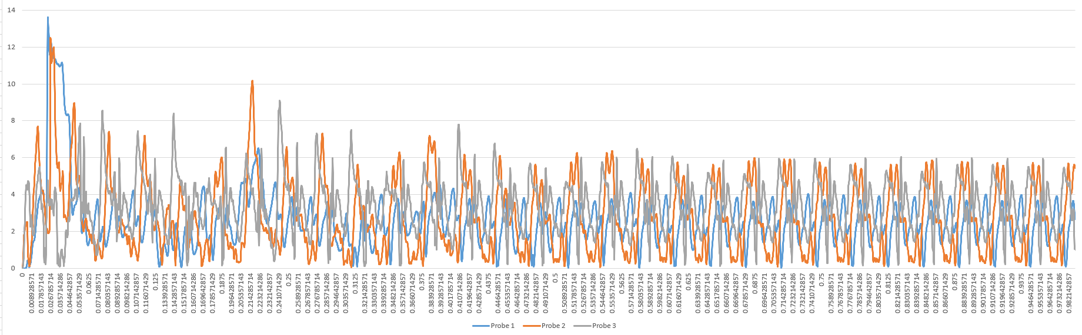
Flow velocity ripple graphs of straight profile lobe pump at probe 1;2;3

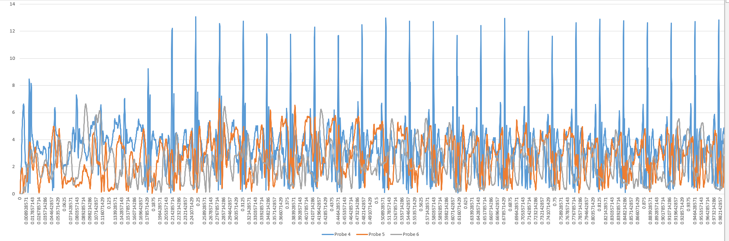
Flow velocity ripple graphs of straight profile lobe pump at probe 4;5;6

Helical Lobe Pump Simulation Data

Helical Lobe Pump Unsteady Pressure Pulsation Graphs at Monitoring Points:

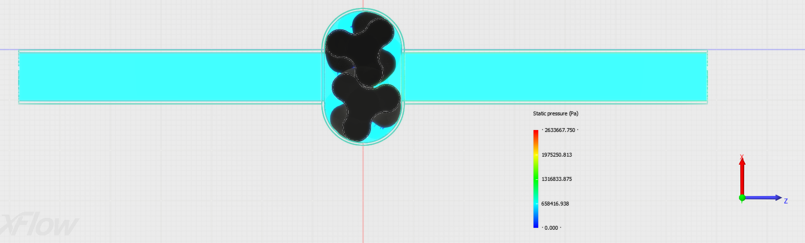

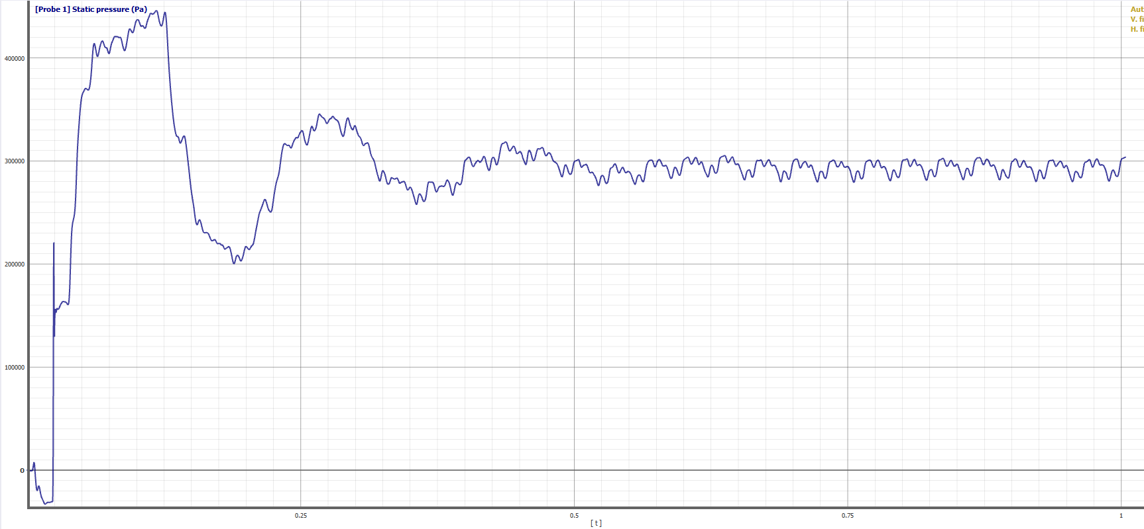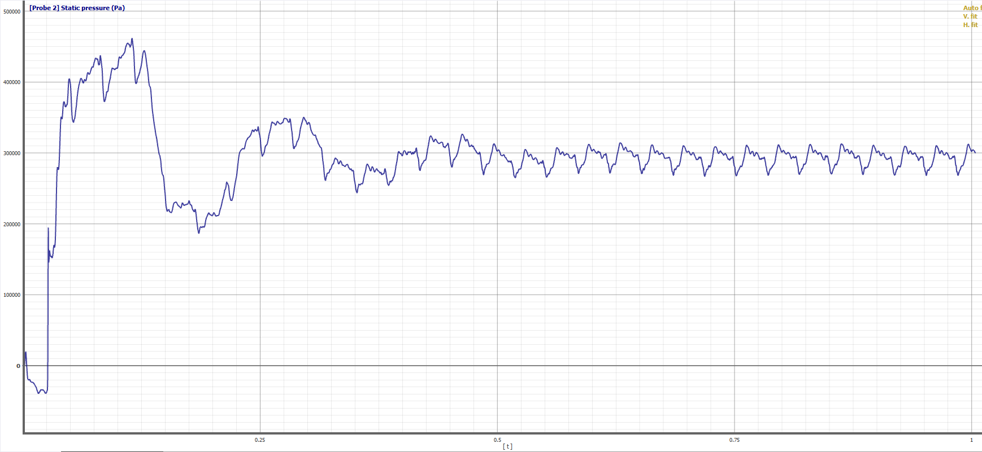
Probe 1 Probe 2

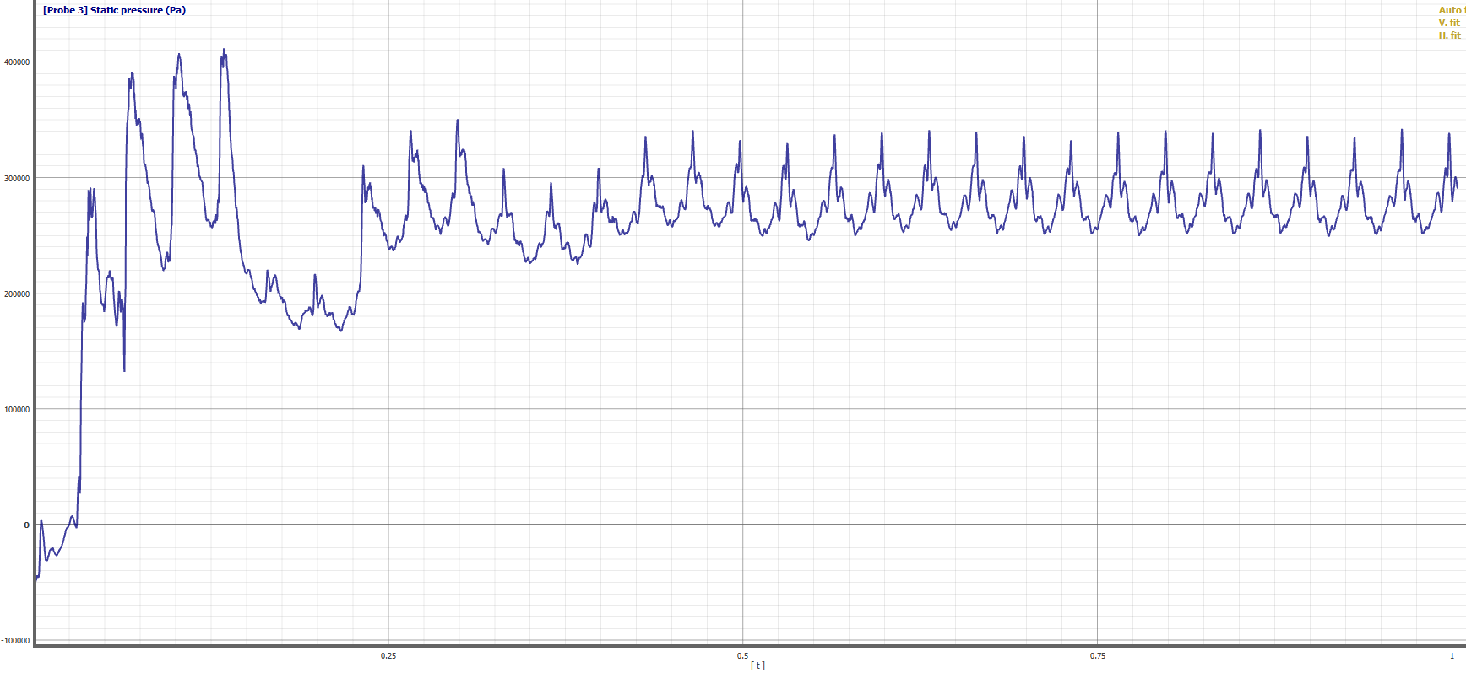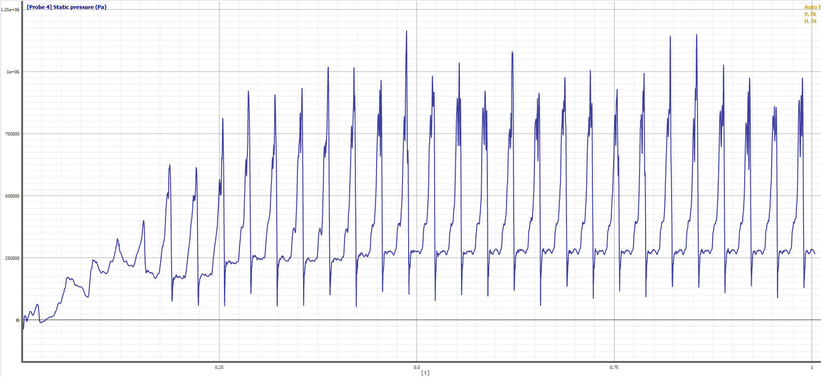
Probe 3 Probe 4

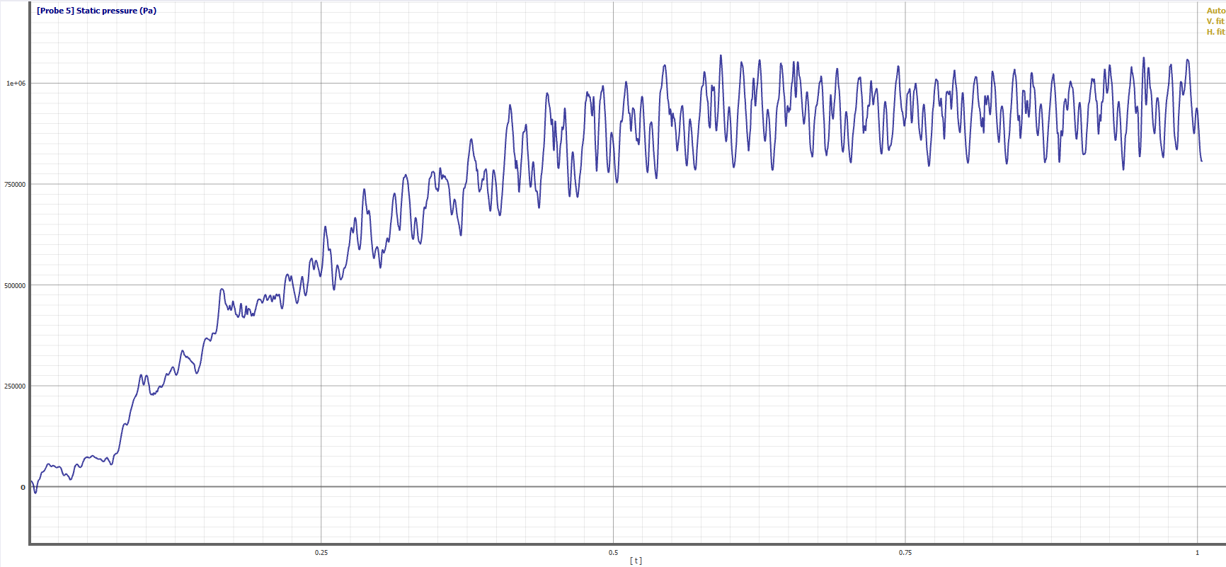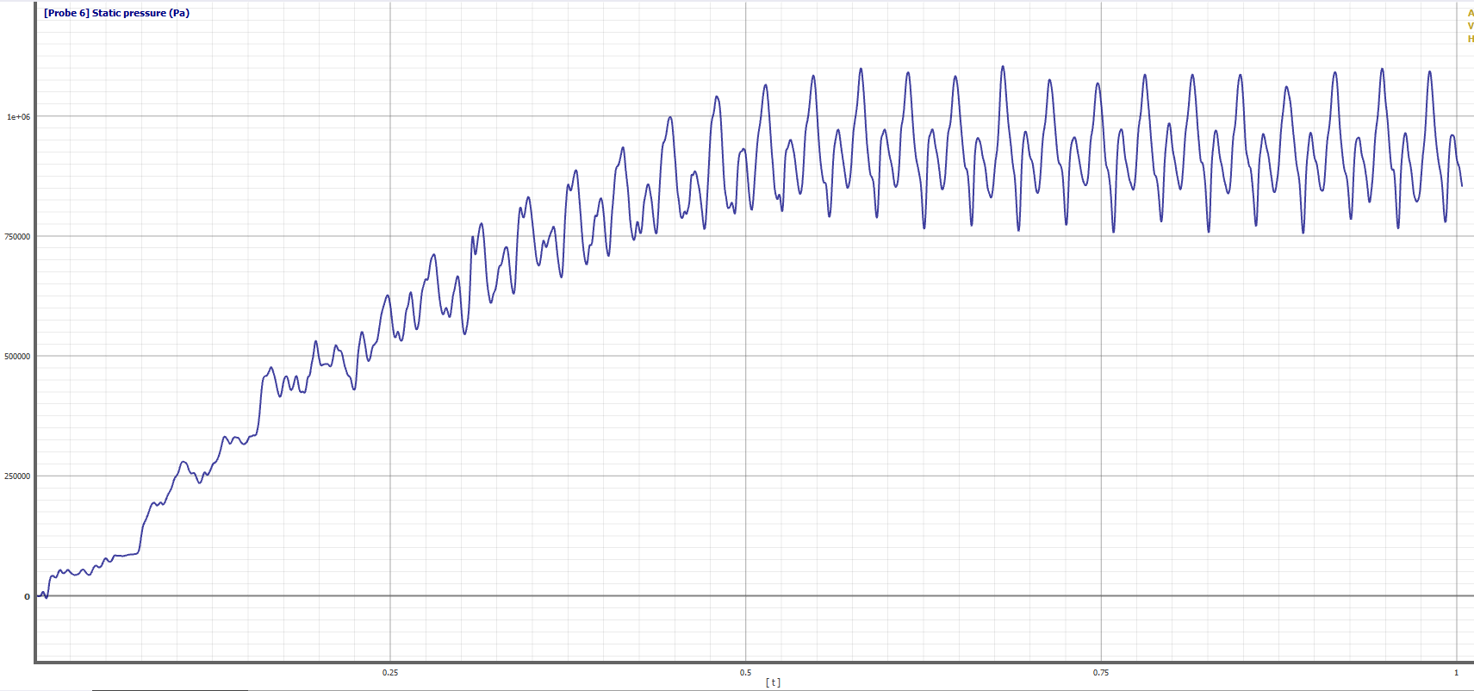
Probe 5 Probe 6

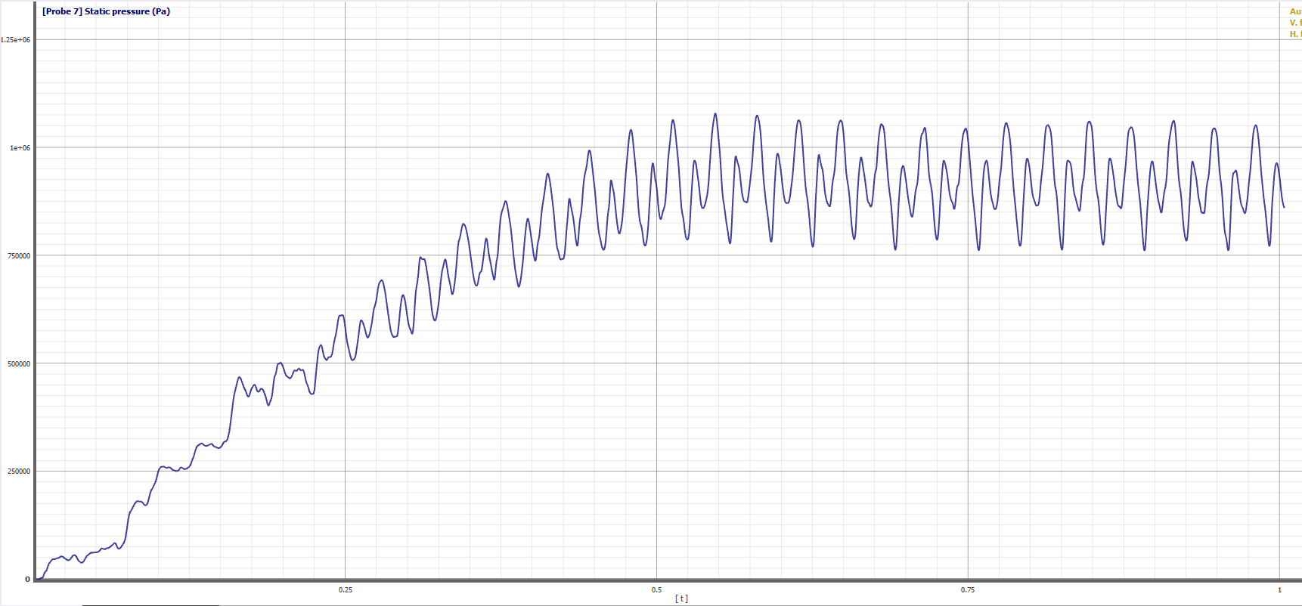
Probe 7

Helical Lobe Pump Pressure Frequency Domains of Monitoring Points:

Each graph below represents frequency domains converted from time domain (time interval selected from 0.8s to 0.9s which is equal to one complete revolution of lobe) using Fourier transformation

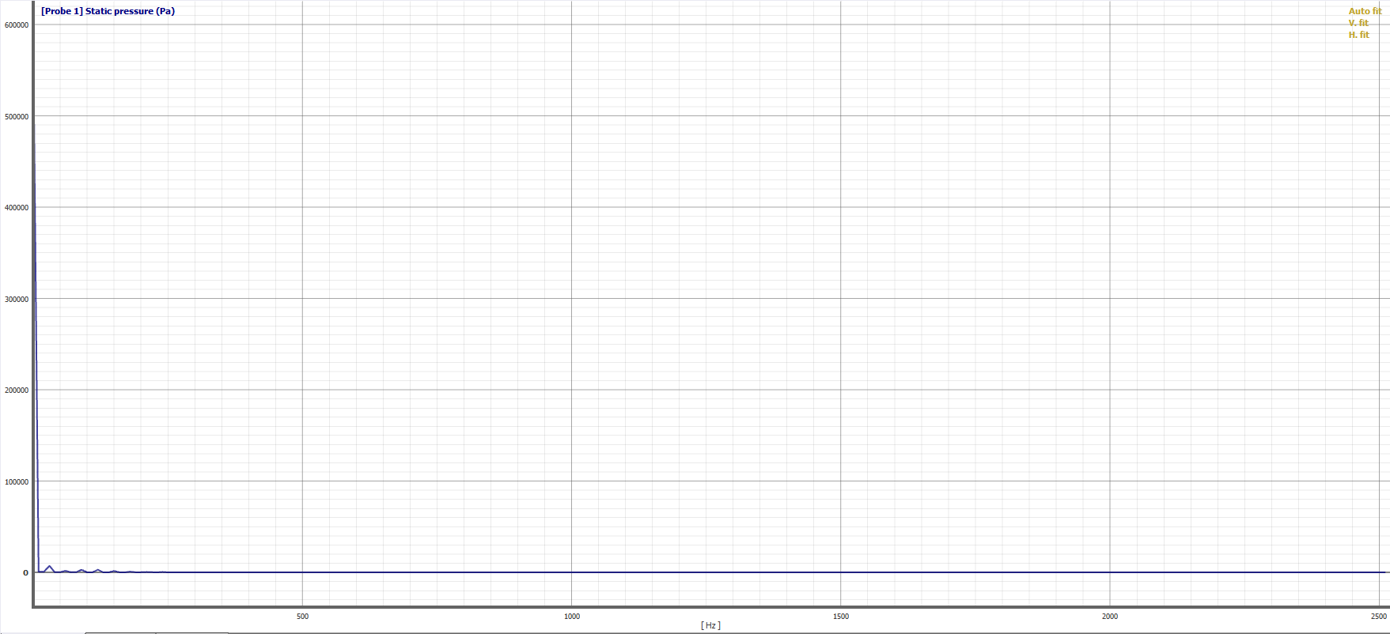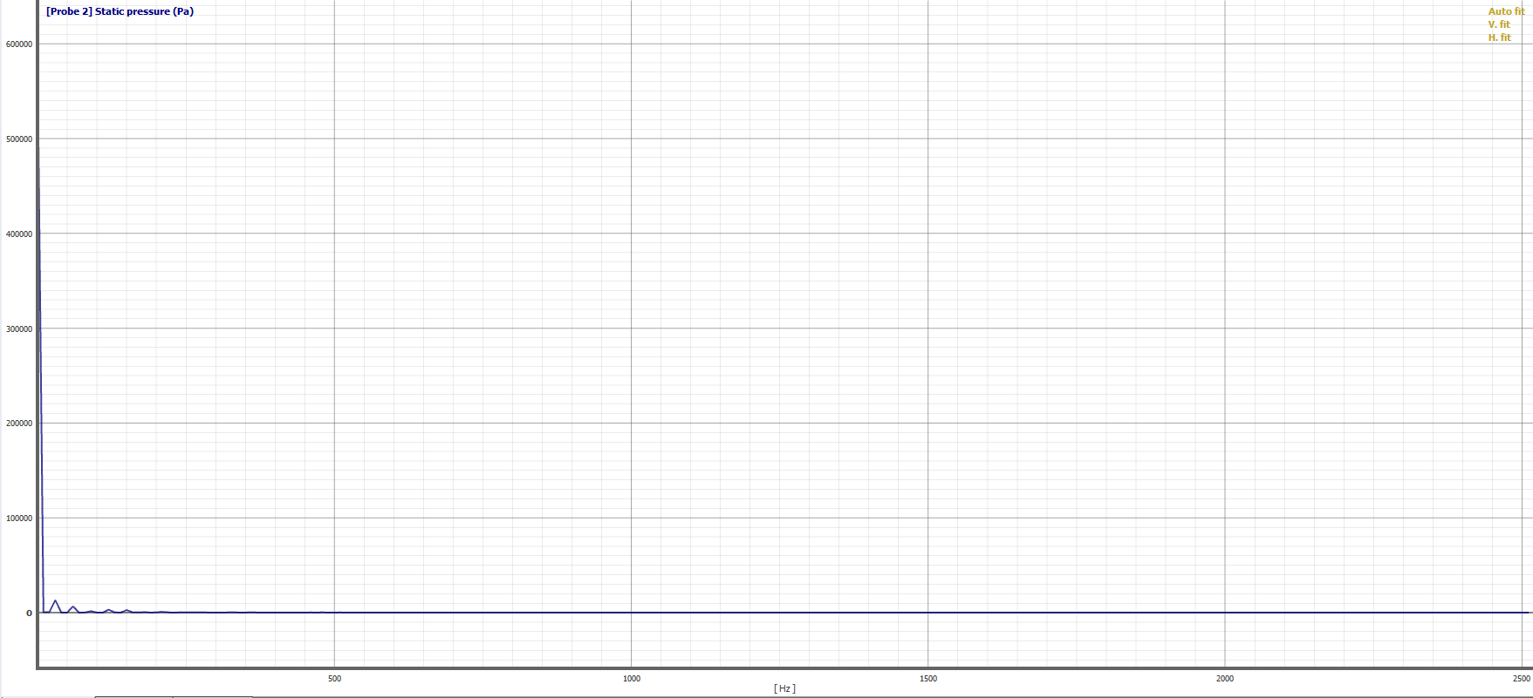
Probe 1 Probe 2

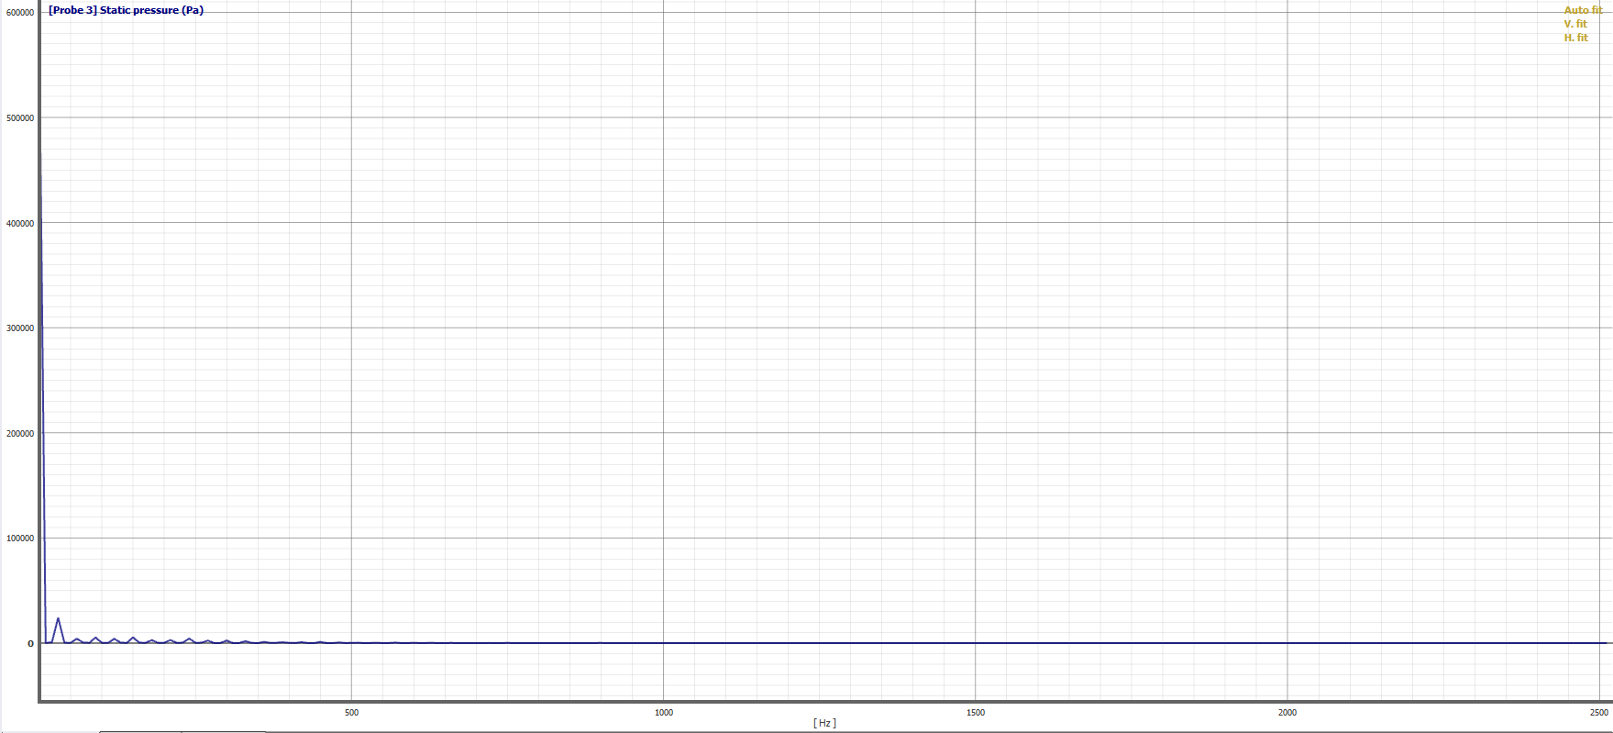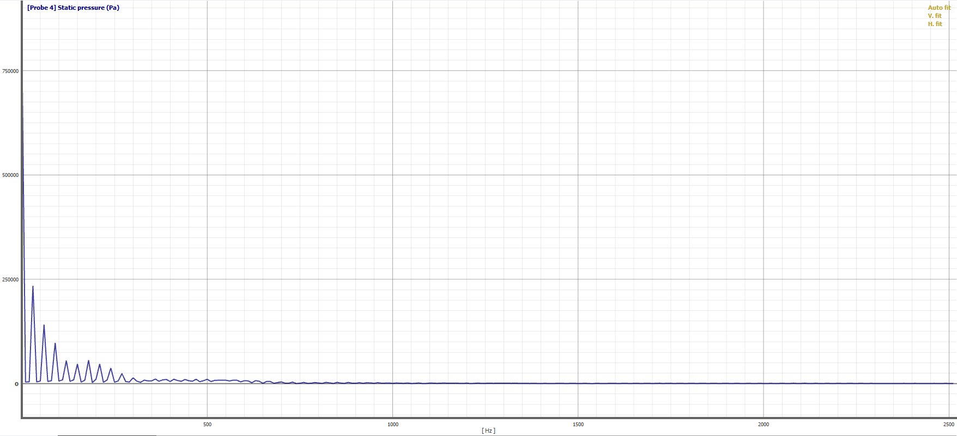
Probe 3 Probe 4

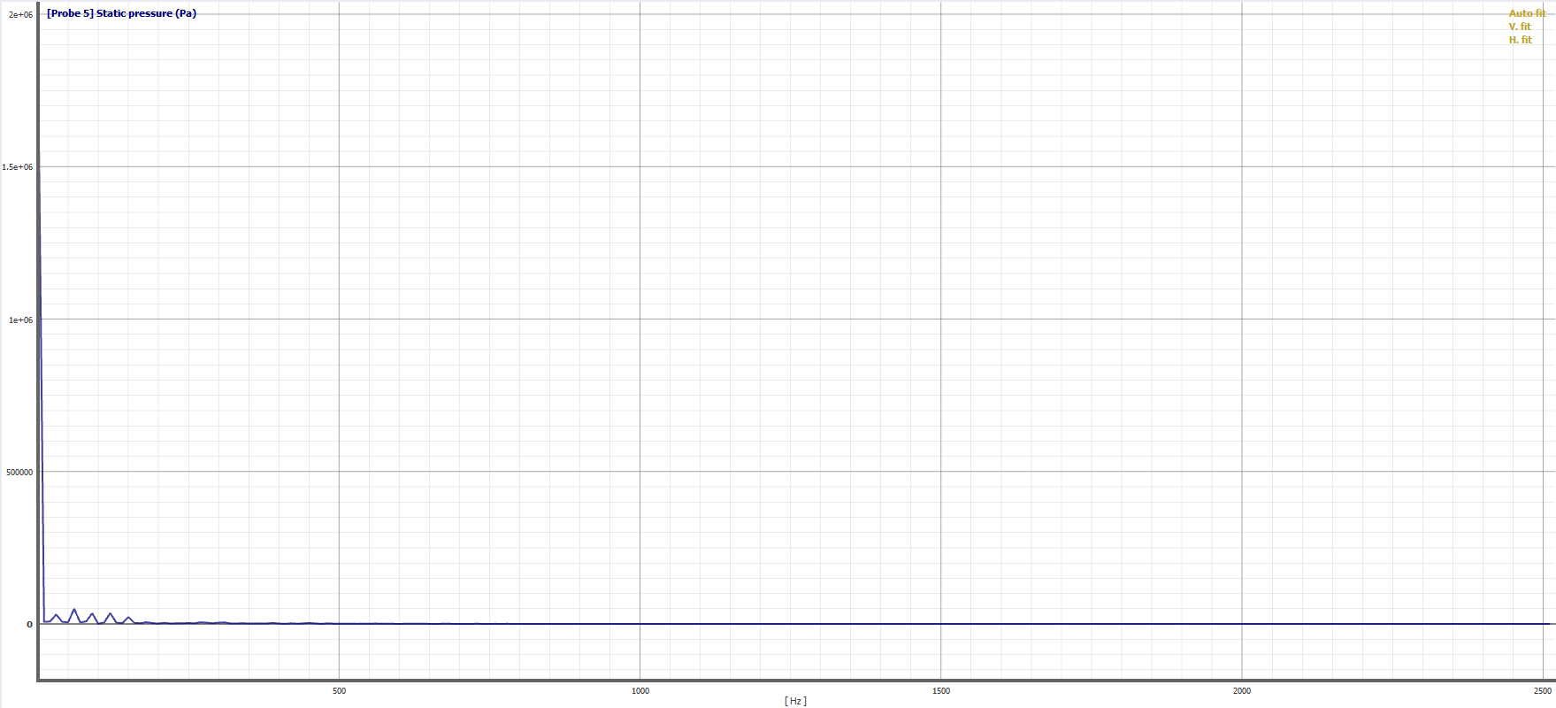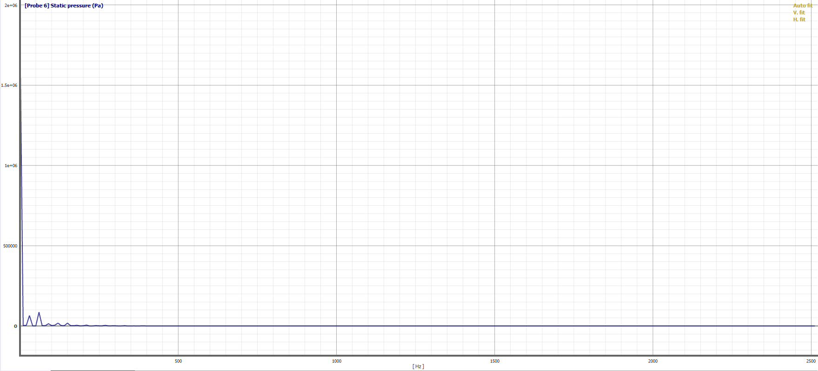
Probe 5 Probe 6

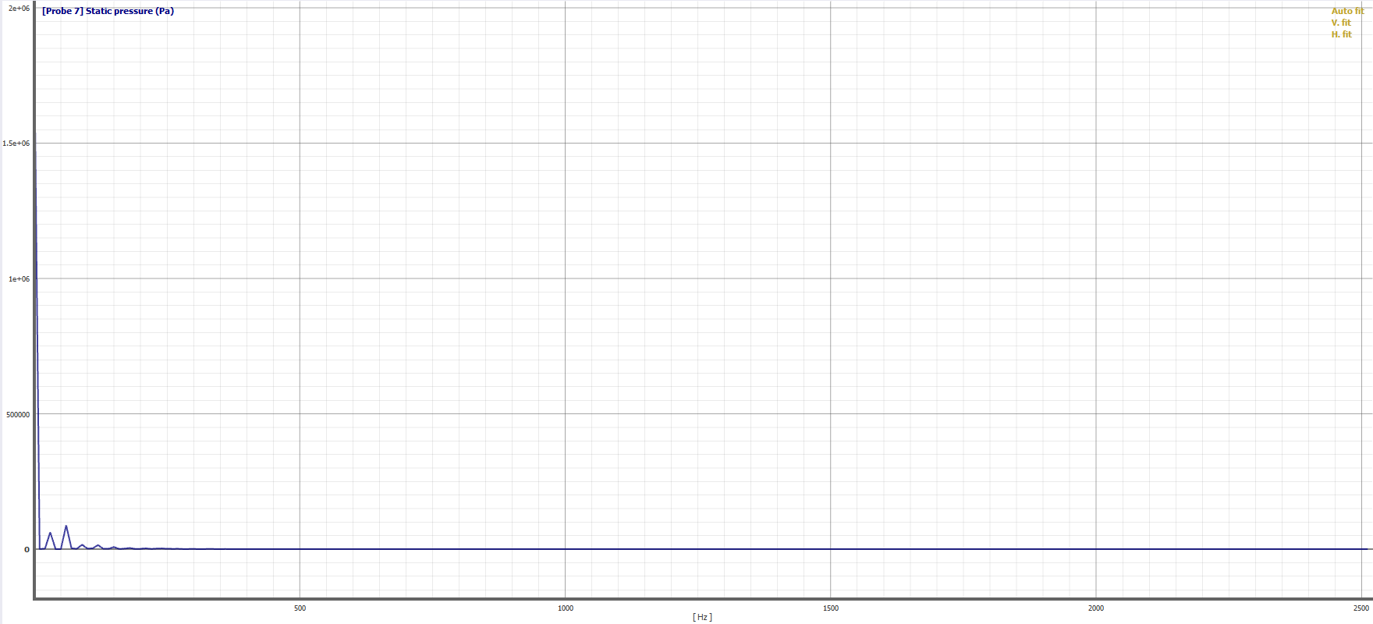
Probe 7

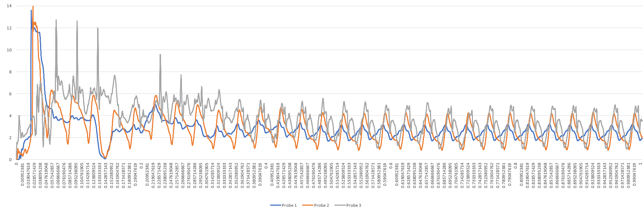
Flow velocity ripple graphs of helical lobe pump at probe 1;2;3

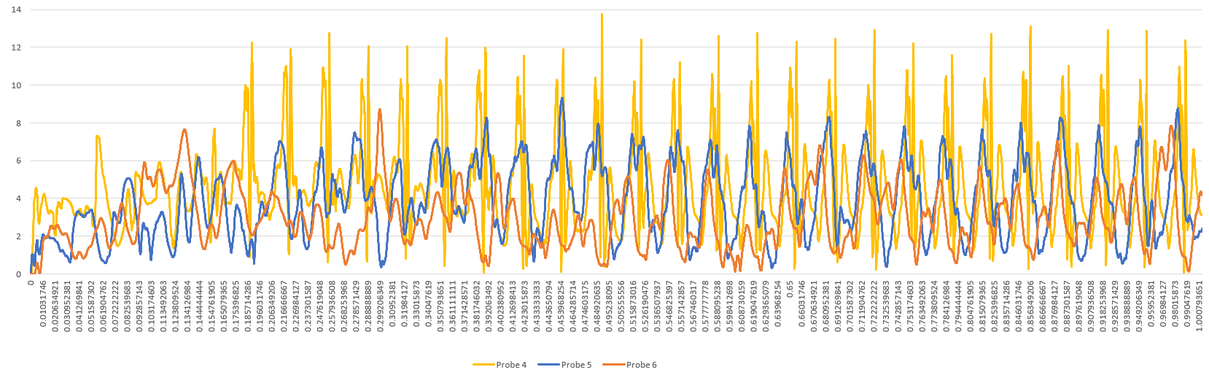
Flow velocity ripple graphs of helical profile lobe pump at probe 4;5;6

When analyzing the time domains of the simulation of each pump, it is observed that the pulsating graphs of pressure values ​​begin to stabilize and become periodic starting from 0.6 seconds, and therefore the data regression in the time domain is applied to the part of the data starting from 0.6 seconds until the end of the simulation period.

Straight Profile Lobe Pump Unsteady Pressure Data Regression Results:

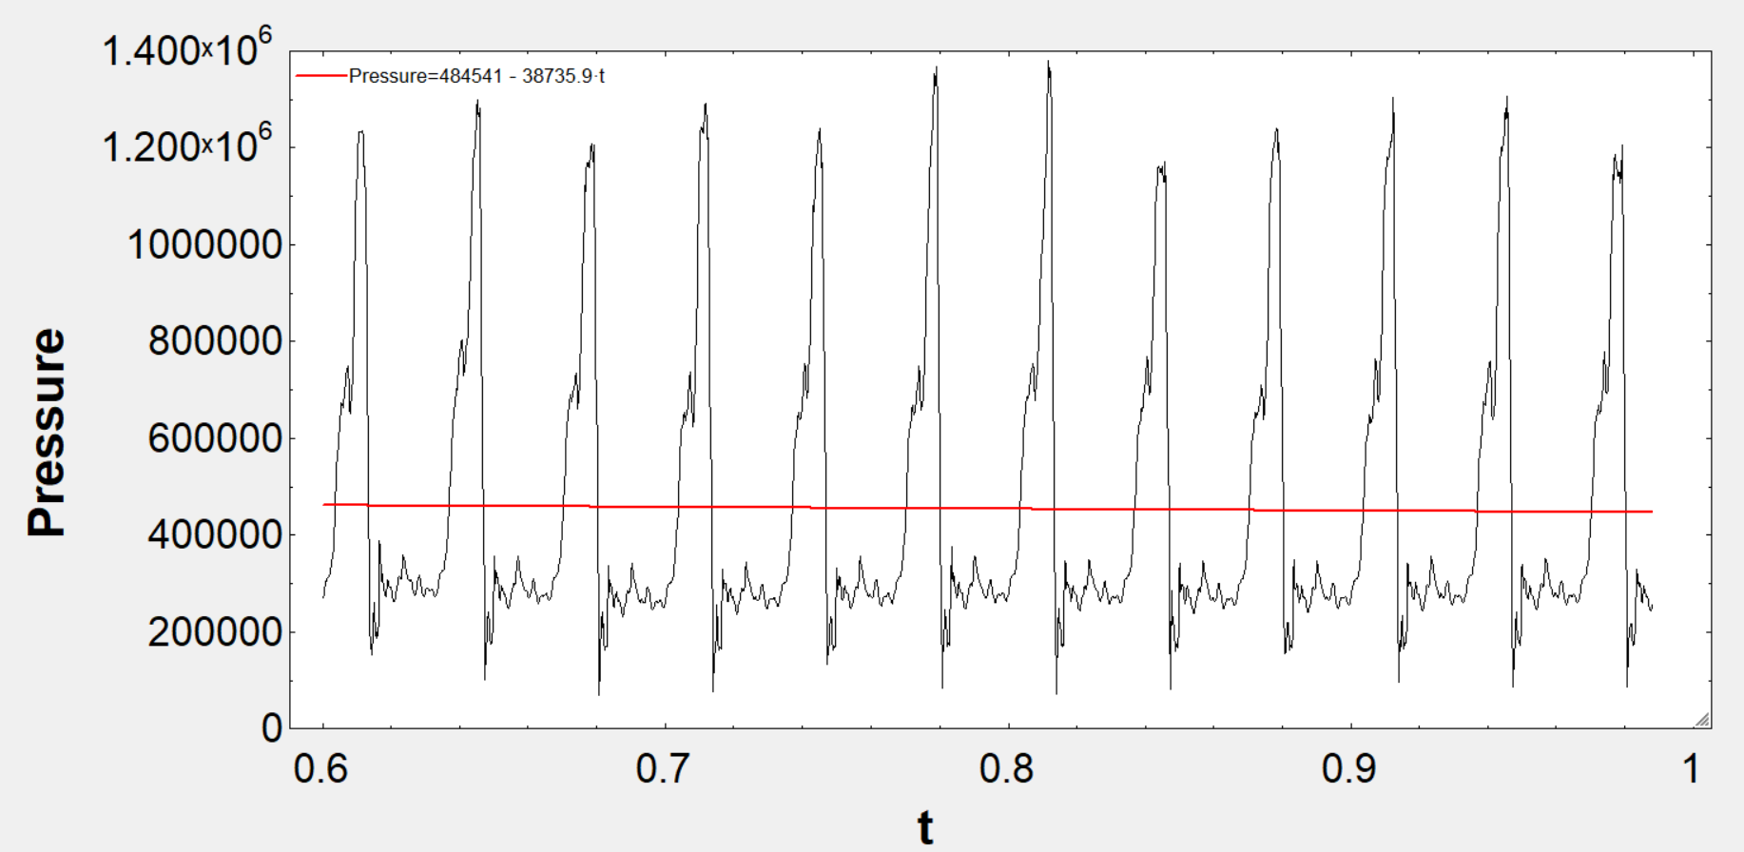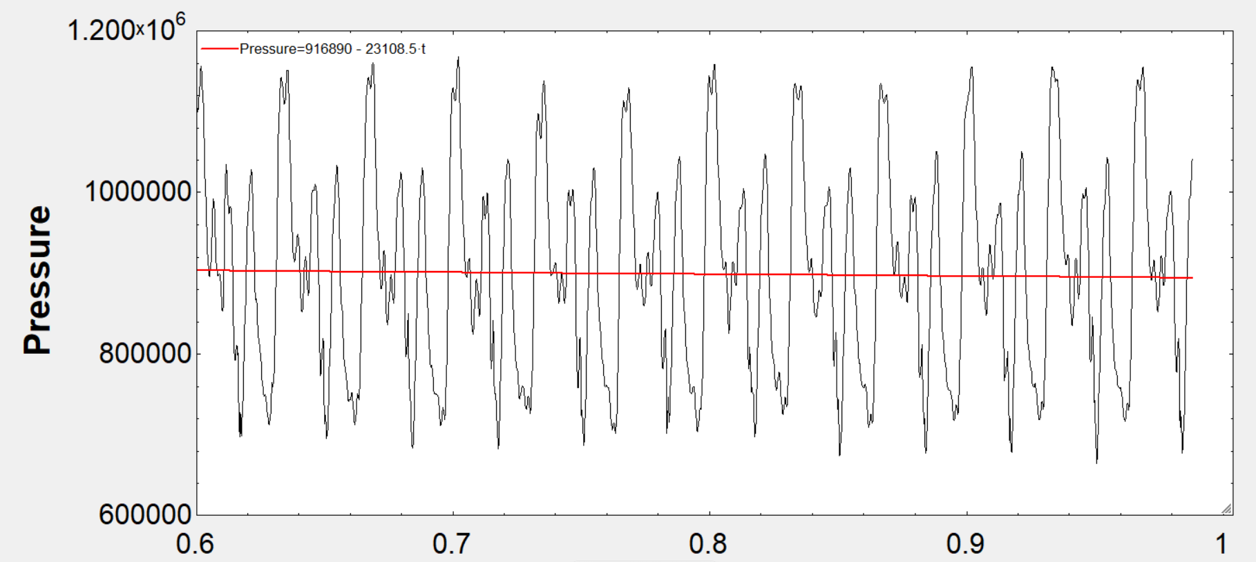
Probe 4 Probe 5
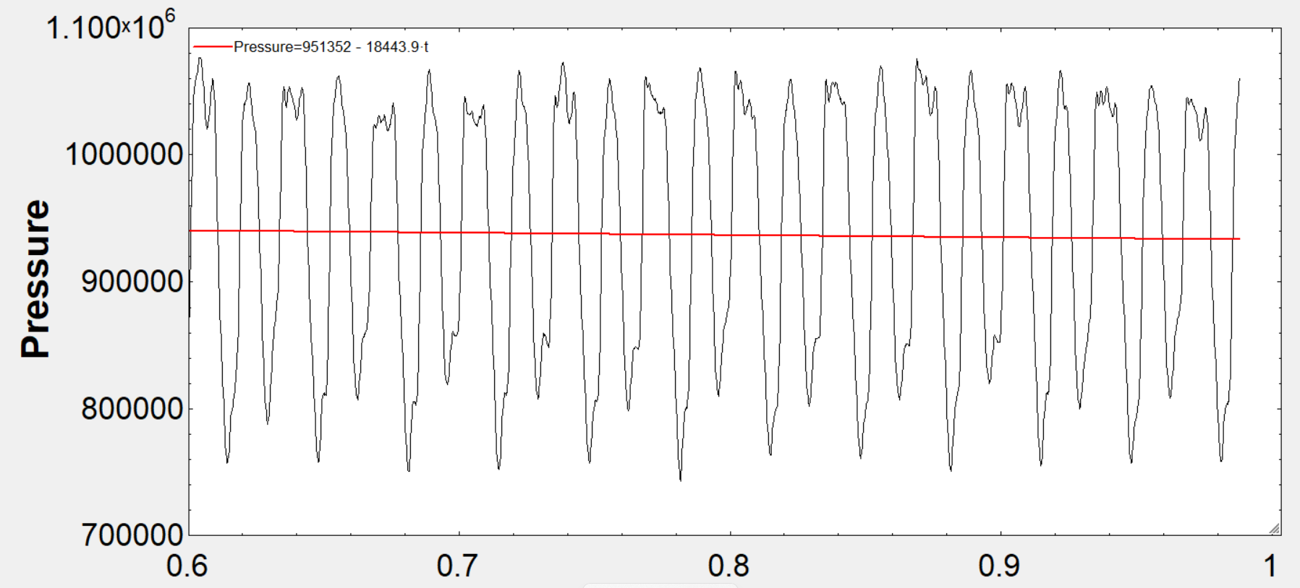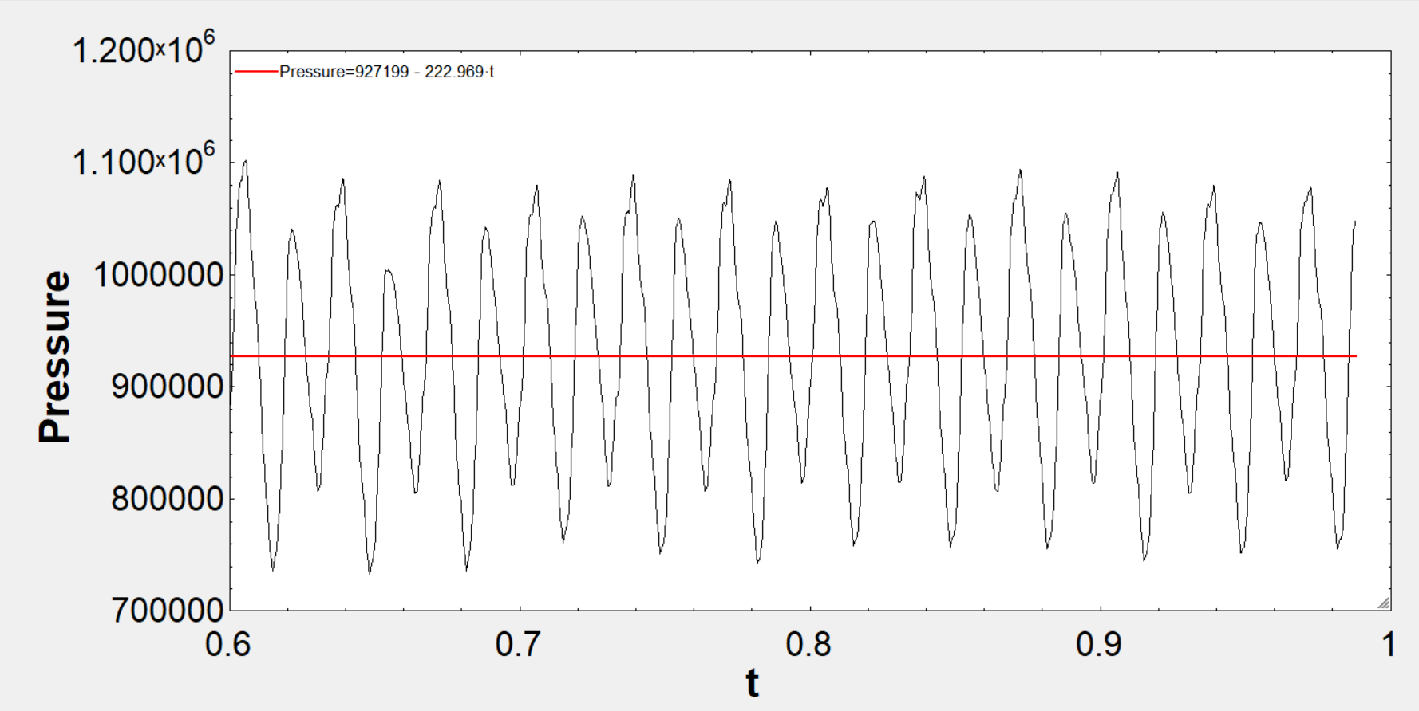
Probe 6 Probe 7

Helical Lobe Pump Unsteady Pressure Data Regression Results:

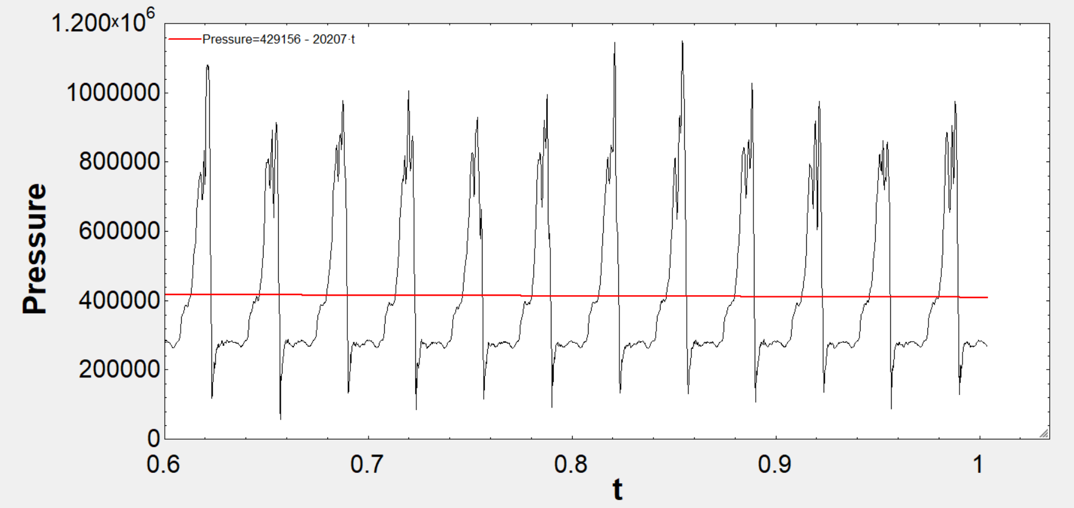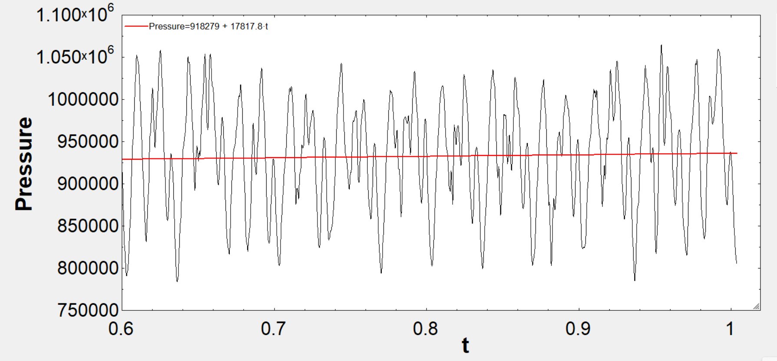
Probe 4 Probe 5

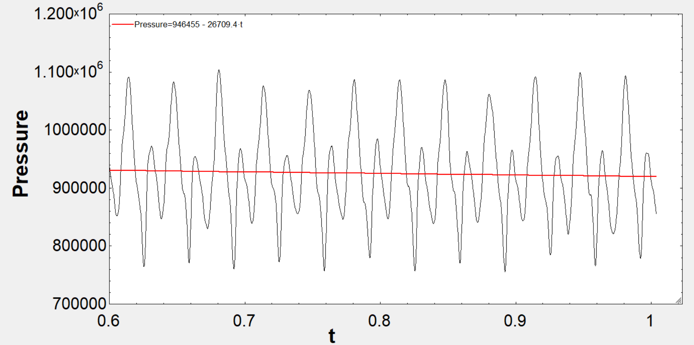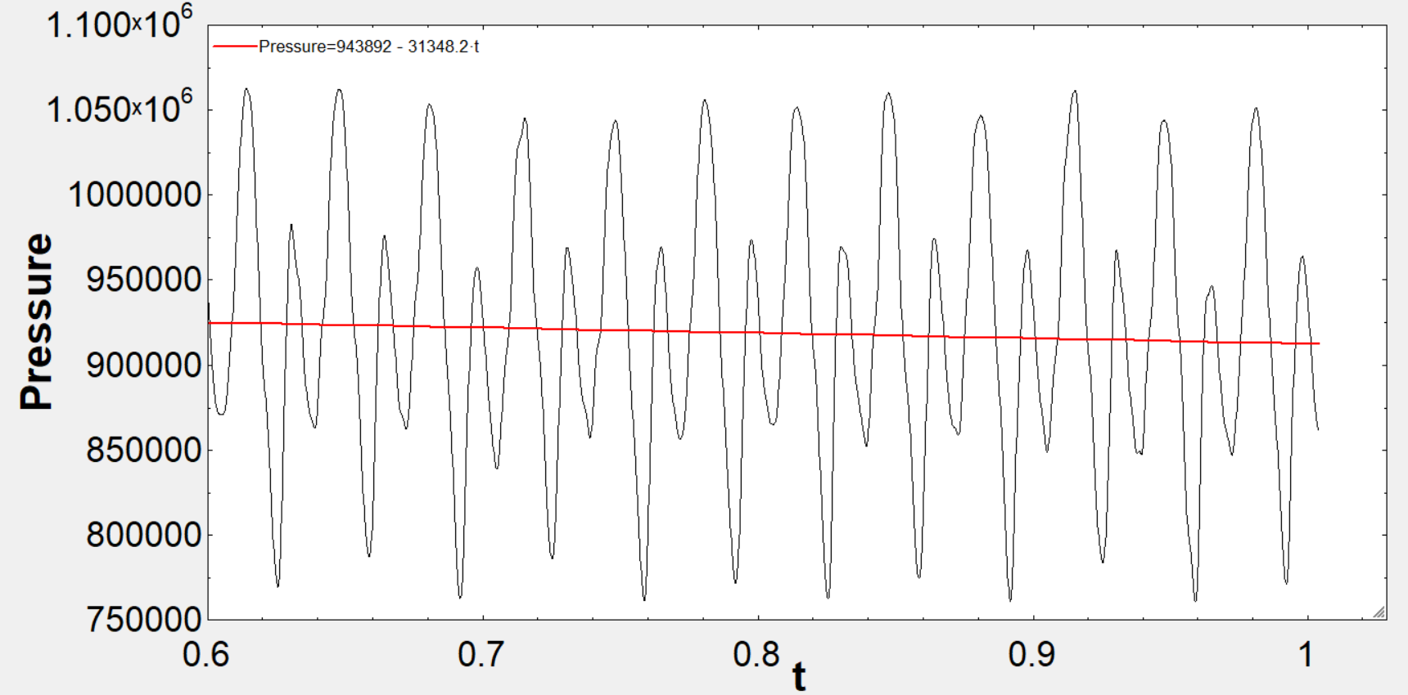
Probe 6 Probe 7

- RESULTS AND DISCUSSION

As a result of the conducted investigations, it was established that substantial disparities exist between the performance indicators of the two selected lobe pump configurations—namely, the straight-profile and the helical-profile designs. These discrepancies are primarily attributed to the geometric distinctions inherent in the respective rotor profiles.
In the case of the straight-profile lobe pump, an analysis of pressure pulsation behavior across the designated monitoring points reveals a distinct trend. As the flow progresses from probe 1 to probe 2—i.e., as it approaches the inlet—the peak-to-peak magnitude of the pressure pulsation exhibits a twofold increase. Subsequently, a gradual attenuation of pulsation is observed as the flow traverses further into the control volume. At probe 3, a modest increase in pulsation intensity is noted. However, a transition from a relatively low-pressure region (probe 3) to a higher-pressure region (probe 4) results in a pronounced surge in the peak-to-peak pulsation value, reaching up to fivefold amplification. Beyond this point, as the flow exits the control volume, the pulsation intensity diminishes accordingly. At the outlet port, the pulsation amplitudes at both peripheral (probe 6) and central (probe 7) locations are observed to be approximately equivalent.
A similar pattern emerges in the frequency domain analysis. As the system progresses from probe 1 to probe 2 (toward the inlet), a slight increase in the amplitude of pressure oscillations is observed. Between probes 2 and 3, no significant variation is detected. However, the transition from probe 3 to probe 4 induces a drastic increase in the pressure amplitude, with a tenfold amplification—mirroring the sharp rise identified in the time domain. Following this peak, the amplitude values taper off as the fluid moves toward the outlet. At probes 6 and 7, the amplitude levels again converge to similar values, irrespective of radial location within the pipe.
In the helical-profile lobe pump, analogous trends are observed, yet with key differences in magnitude. From probe 1 to probe 2, a twofold increase in peak-to-peak pressure pulsation occurs—mirroring the straight-profile case. However, within the initial region of the control volume (from probe 2 to probe 3), the pulsation increase is markedly more significant than in the straight-profile design—approximately two times greater. Subsequently, as in the previous case, a substantial escalation in pulsation occurs from probe 3 to probe 4; however, the helical-profile pump demonstrates a tenfold increase in this region, doubling the corresponding rise observed in the straight-profile pump. Afterward, pulsation intensity declines as the fluid proceeds through the outlet pathway.
In the frequency domain, a more pronounced disparity between the two pump types is apparent. At probes 1 and 2, the pressure amplitude in the helical-profile pump is two times greater compared to the slight increase observed in the straight-profile pump. Further inside the control volume (at probe 3), a continued rise in amplitude is recorded. The transition from probe 3 to probe 4 results in a dramatic twentyfold increase in amplitude—twice that observed in the straight-profile configuration. Following this spike, a downward trend in pressure amplitude is evident at probe 5. Notably, in contrast to the straight-profile pump, the pressure amplitude rises again at the outlet port (probes 6 and 7), with values doubling relative to those at probe 5.
A comparative assessment of pressure pulsation performance reveals that the helical-profile lobe pump exhibits significantly improved behavior near the inlet region. Specifically, at probes 1 and 2, the peak-to-peak pulsation values in the helical configuration are approximately five times lower than those in the straight-profile counterpart. As the flow advances into the control volume, this performance differential diminishes—decreasing to a factor of 2.5 at probe 3 and narrowing further to approximately 3 bar at probe 4. A partial resurgence in performance advantage is observed at probe 5 (roughly a twofold improvement in favor of the helical pump); however, this difference becomes negligible at the outlet (probes 6 and 7).
A parallel trend is identified in the frequency domain analysis. At the inlet (probes 1 and 2), pressure amplitudes in the helical-profile pump are 3–4 times lower than those in the straight-profile pump. Yet, the magnitude of this advantage diminishes more rapidly within the control volume compared to the time-domain results, becoming marginal at probes 3 and 4. At probe 5, the performance advantage of the helical design resurfaces (approximately threefold), though it again decreases significantly at probes 6 and 7.
Based on the non-linear least squares regression analysis applied to the unsteady pressure fluctuation data, it can be concluded that the pressure generation capacities—i.e., the average pressure values generated within both the control volume and the outlet region—do not differ significantly between the two pump types. Hence, while pulsation behavior varies markedly due to rotor geometry, the mean pressure output remains largely invariant across configurations.

Availability of data and materials

The author will provide the datasets used and analyzed during the current study upon reasonable request. The study’s supporting data, according to the author, are included in the journal and its supplemental materials.

References

Mimmi, G., & Pennacchi, P.(1999). Analytical model of a particular type of positive displacement blower. Proceedings of the Institution of Mechanical Engineers, Part C: Journal of Mechanical Engineering Science,213(5), 517–526. https://doi.org/10.1243/0954406991522743

Valdès, L. C., Barthod B., & Perron, Y.L. (1999). Accurate prediction of internal leaks in stationary dry roots vacuum pumps. Vacuum, 52(4), 451–459. https://doi.org/10.1016/S0042-207X(98)00330-3

Vogelsang, H., Verhülsdonk, B., Türk, M., & Hörnig, G. (1999). Pulsation problems in rotary lobe pumps. World Pumps,389,45–52 https://doi.org/10.1016/S0262-1762(00)87679-8

Costopoulos, T., Kanarachos, A., & Pantazis, E. (1988). Reduction of delivery fluctuation and optimum tooth profile of spur fear rotary pumps. Mechanism and Machine Theory,23(2), 141–146. https://doi.org/10.1016/0094-114X(88)90091-2

Tong, S. H., & Yang, D. C. H. (2005). Rotor profiles synthesis for lobe pumps with given flow rate functions. Journal of Mechanical Design,127(2), 287–294. https://doi.org/10.1115/1.1798271

Wang, J., Jiang, X., & Cai, Y. (2015). Investigation of a novel circular arc claw rotor profile for claw vacuum pumps and its performance analysis. Vacuum, 111, 102–109. https://doi.org/10.1016/j.vacuum.2014.10.003

Mimmi, G., & Pennacchi, P.(1994). Flow rate regularity in rotary trochoidal-lobe pumps. ASME machine elements and machine dynamics, 71, 295–302.

Sun, S.K., Jia, X.H., Xing, L.F., & Peng, X.Y.(2018). Numerical study and experimental validation of a roots blower with backflow design. Engineering Applications of Computational Fluid Mechanics,12(1), 282–292.

Peng, Q.L., Gui, L.J., & Fan, Z.J.(2018). Numerical and experimental investigation of splashing oil flow in a hypoid gear box. Engineering Applications of Computational FluidMechanics,12(1), 324–333. https://doi.org/10.1080/19942060.2018.1432506

Huang, Z. F., & Liu, Z. X. (2009). Numerical study of a positive displacement blower. Proceedings of the institution of mechanical engineers, Part C: Journal of Mechanical Engineering Science,223(10), 2309–2316. https://doi.org/10.1243/09544062JMES1503

Yang, D.C.H., & Tong, S.H.(2002). The specific flow rate of deviation function based lobe pumps-derivation and analysis. Mechanism and Machine Theory,37(10), 1025–1042. https://doi.org/10.1016/S0094-114X(02)00065-4

Ma,Y.,Luo,H.S., Zhang,Z.H., Zhou, S.Q., & Deng,H.Y. ( 2017). Numerical modeling of dynamic characters forcombined valves in multiphase pump. Engineering Applications of Computational Fluid Mechanics,11(1), 328–339. https://doi.org/10.1080/19942060.2017.1292409

Hwang, Y. W., & Hsieh, C. F. (2006). Study on high volumetric efficiency of the roots rotor profile with variable trochoid ratio. Proceedings of the Institution of Mechanical Engineers, Part C: Journal of Mechanical Engineering Science,220(9),1375–1384. https://doi.org/10.1243/09544062JMES176

Hsieh, C. F. (2015). A new curve for application to the rotor pro-file of rotary lobe pumps. Mechanism and Machine Theory,87, 70–81. https://doi.org/10.1016/j.mechmachtheory.2014.12.018

Kang, Y. H., & Vu, H. H. (2014). A newly developed rotor pro-file for lobe pumps: Generation and numerical performance assessment. Journal of Mechanical Science and Technology,28(3), 915–926. https://doi.org/10.1007/s12206-013-1159-7

Li,Y.B.,Jia,K., Meng,Q.W., Shen,H., & Sang,X.H.(2013). Flow simulation of the effects of pressure angle to lobe pump rotor meshing characteristics. IOP Conference Series: Mate-rials Science and Engineering,52(3), 1–7.

Funding
This study did not receive a fund from any resource.

Competing interests
The author declares that they have no competing interests.

